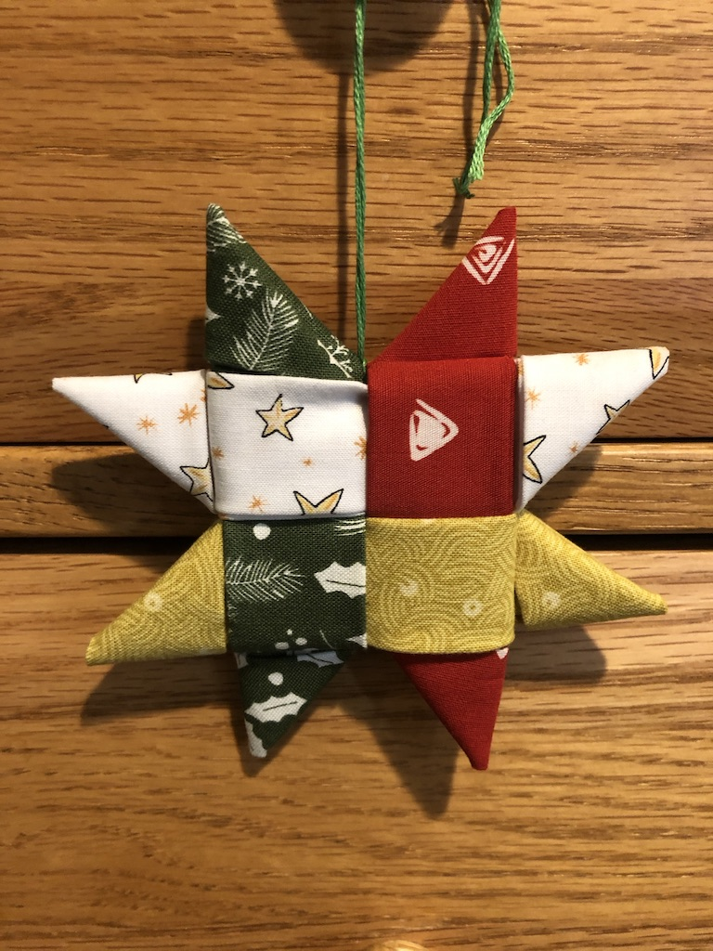

Scandinavian Folded Fabric Star

Your star kit contains 4 pieces of cotton fabric, each, 4” by 16”, also 10” of embroidery floss, and the pattern instructions. You will need an iron, a needle with a big eye and a sharp point, and a small amount of white glue or fabric glue. If you use your own fabric, make sure it’s a sturdy cotton, like quilting cotton. Some people spray it with spray starch to make it easier to work with. I haven’t found that necessary.

First the ironing:

1. Fold each fabric strip in half, wrong sides together, matching the raw edges, and press.
2. Open it up, fold both edges into the mid-line and press. Fold those folds in to the center and press, making a 1 inch strip with no raw edges.
4. Fold each strip in half at the center.

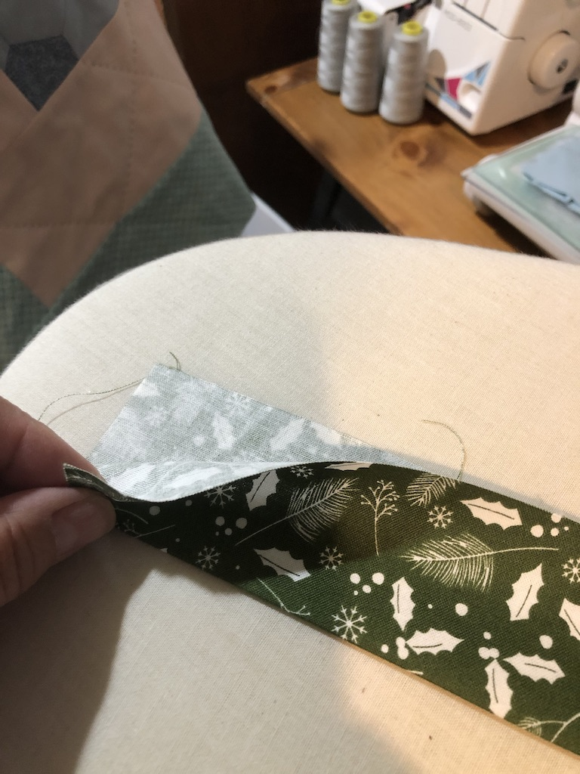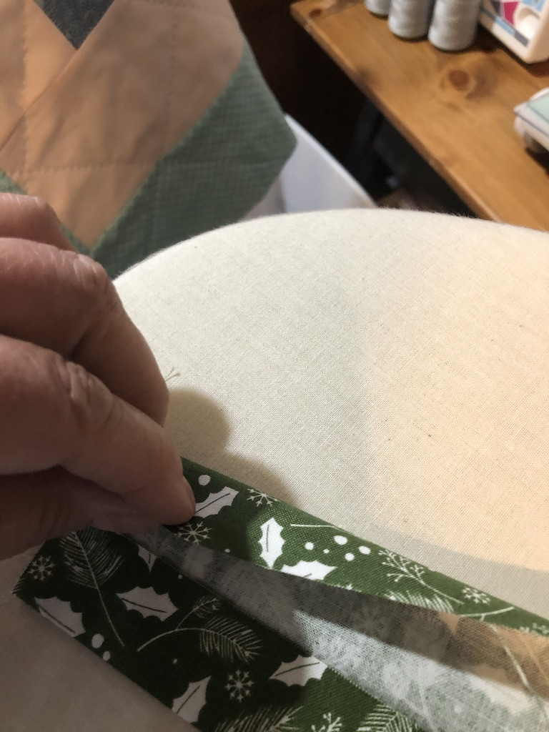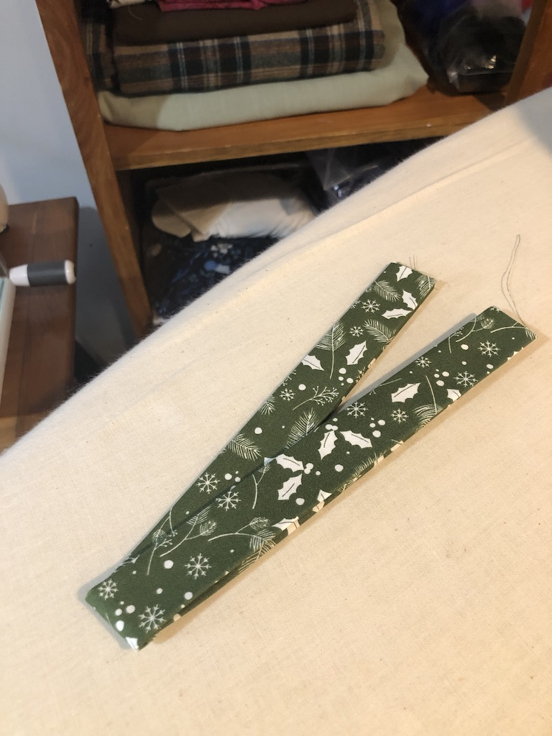

5. Lay the strips like this (below) with the folds in the places indicated.
6. Weave them, starting anywhere, tucking the raw ends in thru the nearest folded strip.
7. Tighten up the woven pieces by sliding them to the center.

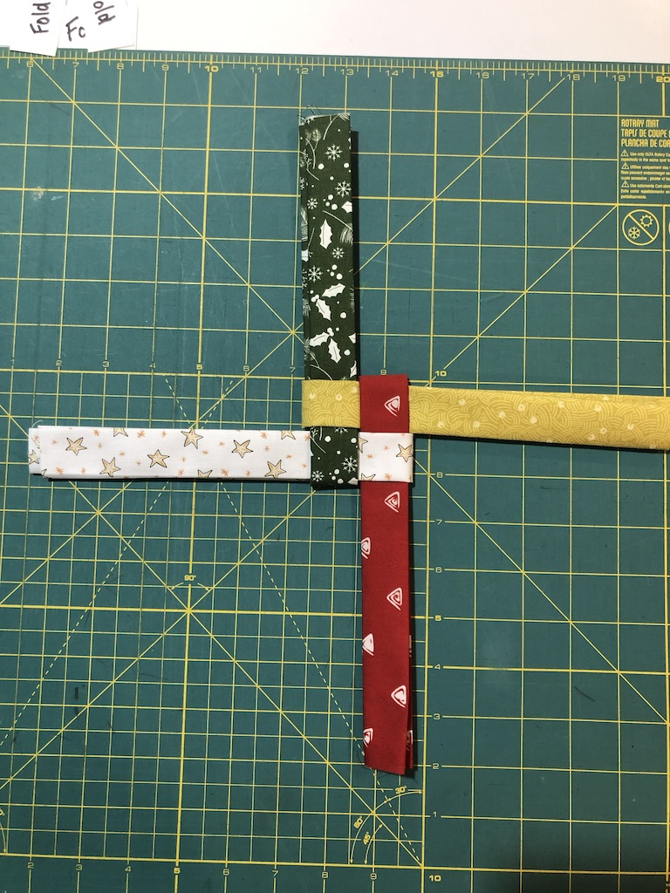
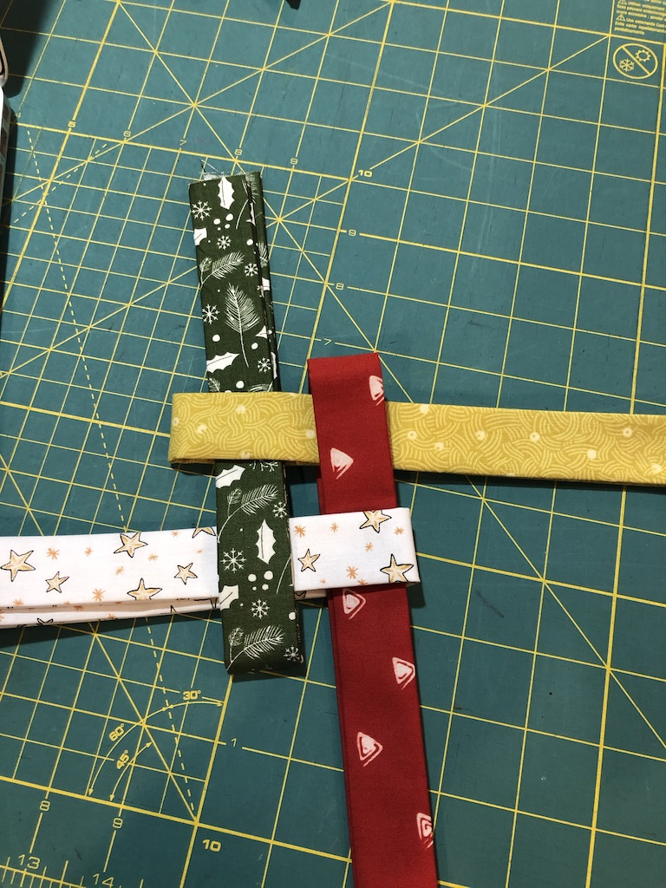
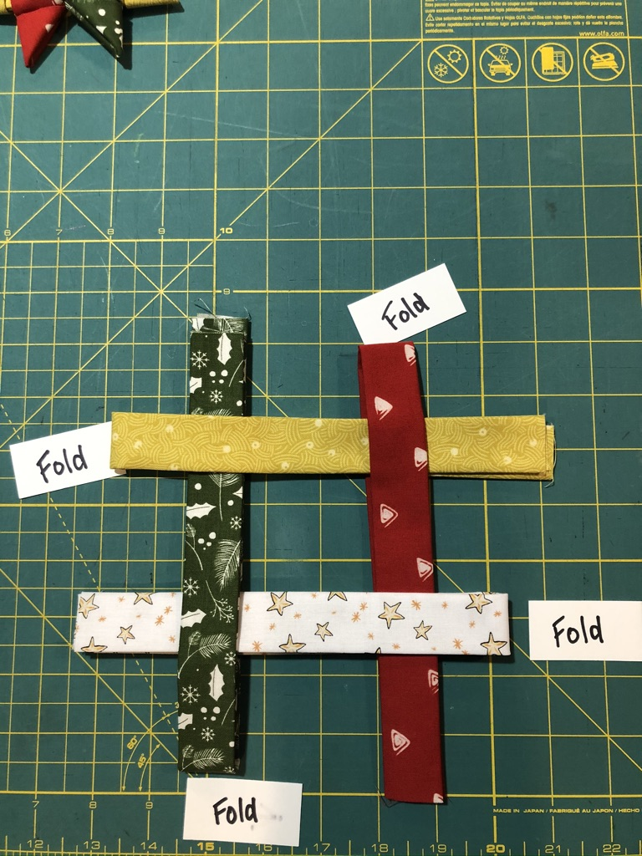

7. Flip the whole thing over. Beginning with the top left, (white), fold the top layer over the center.
8. Moving clockwise, fold each top piece over the center square.
and tuck the last strip under (green under white) to secure it. Pull all the ends snug. It doesn’t matter that the ends are different lengths.

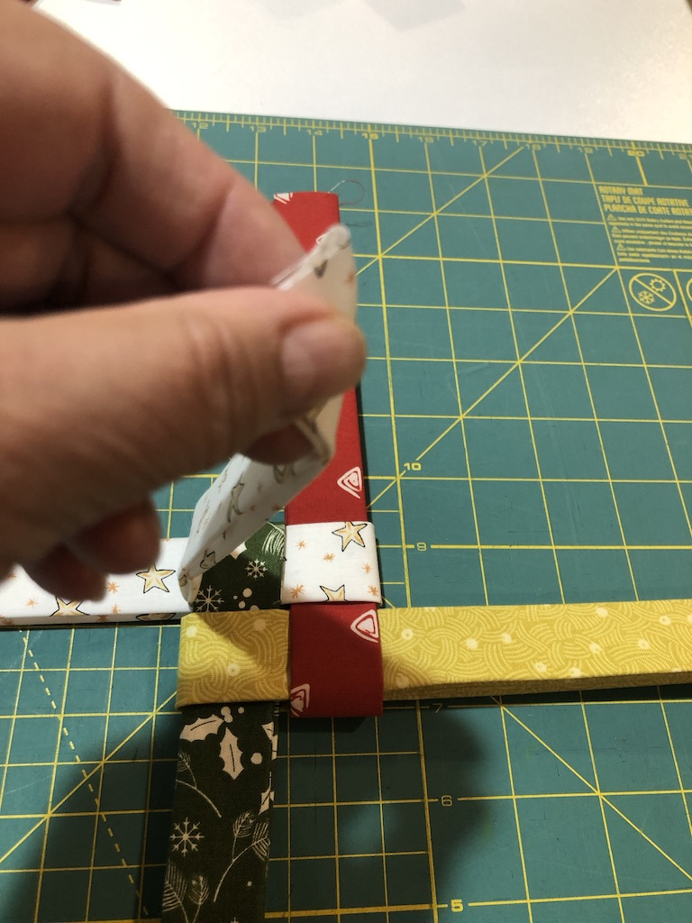
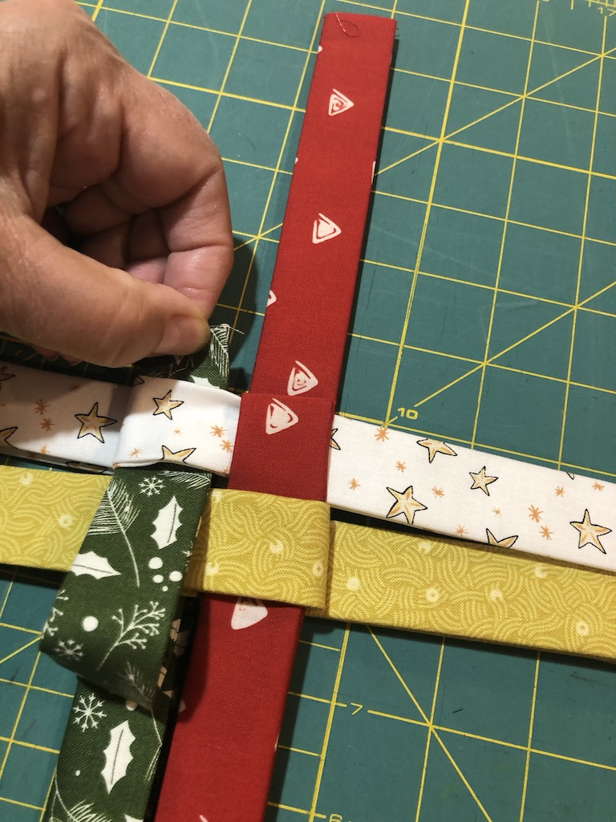
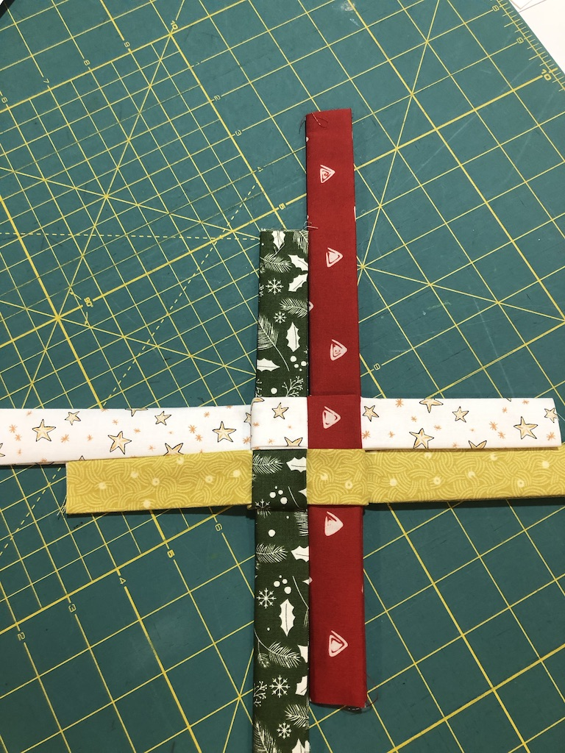

9. Now you make 8 points. Fold any top right strip over, away from the center, making a right angle, finger press.

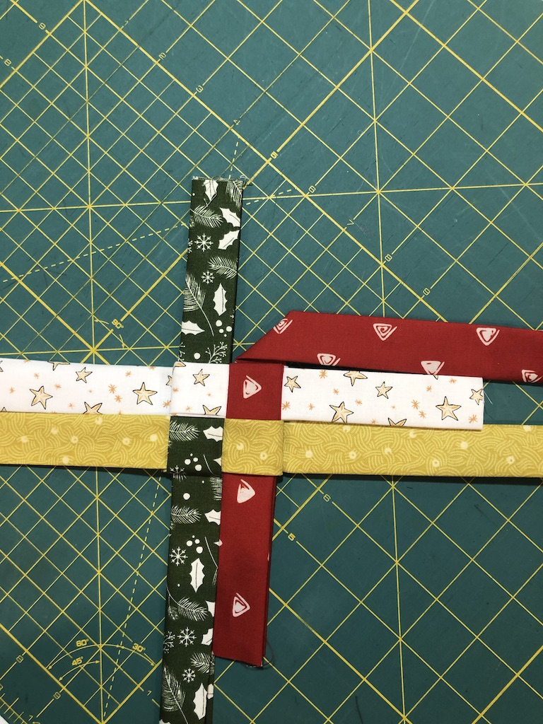

10. Flip the whole thing over, holding that fold, and fold the end straight down, parallel to the center square.
11. Fold that end over towards the center, trim the end and tuck it under the strip below. Keep holding the point. A knitting needle or chopstick can be helpful.

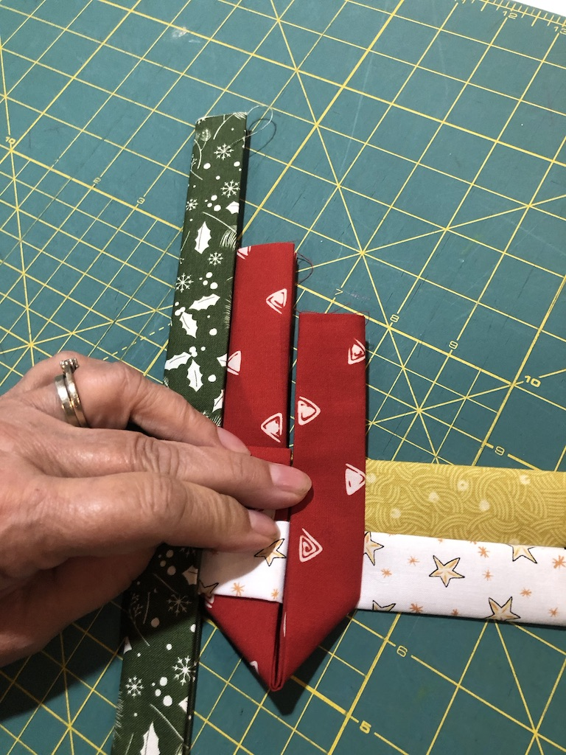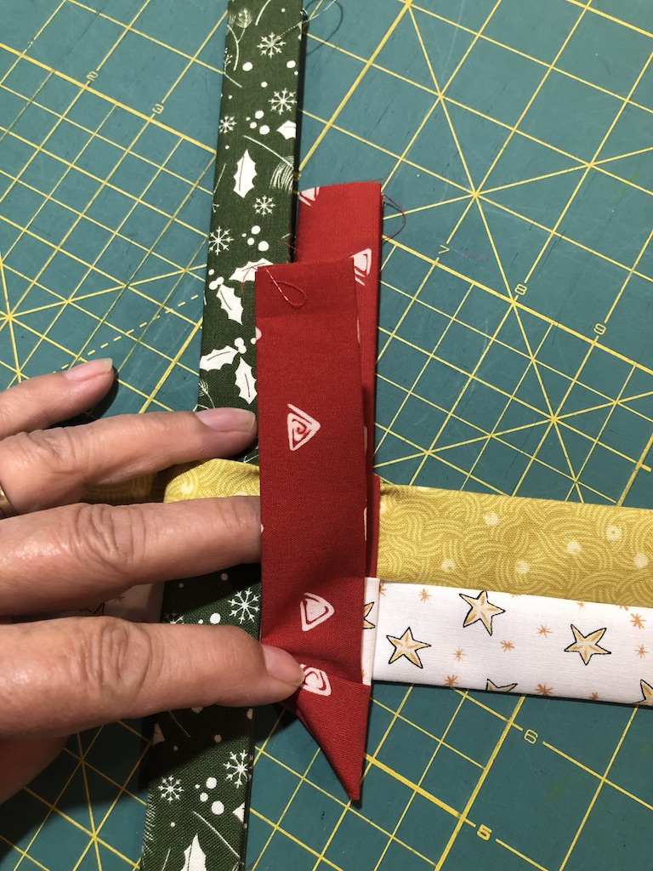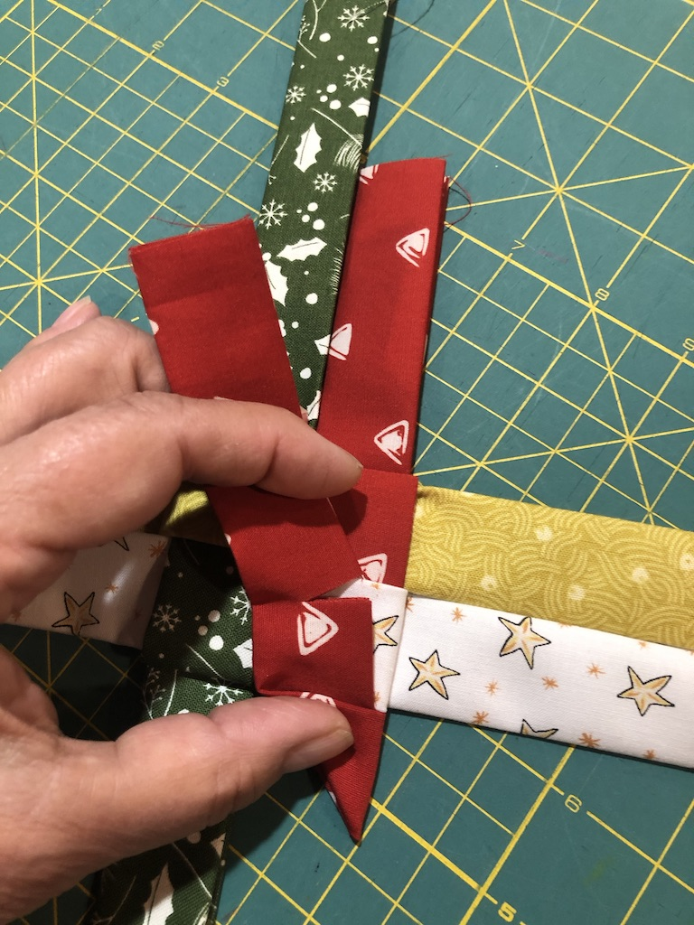

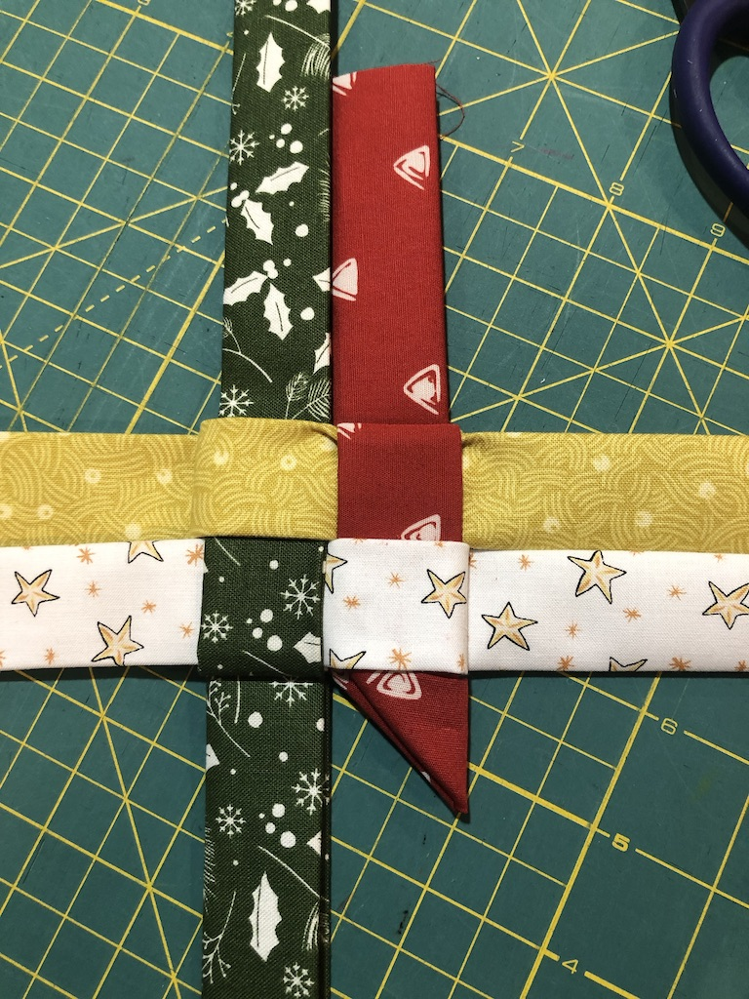

12. Continue around all eight points, repeating this sequence, starting with instruction #9: Fold, (always away from the center), flip, fold down, trim and tuck.

3. Thread the needle with about 10 inches of embroidery floss and sew a loop between two points. (There is a spot between the star points that can’t be pulled out). Put a small drop of glue inside the tucks to secure them. I put a heavy book on top and let the glue dry.

