HAMPSHIRE COUNTY 4H FAIR
July 8, 2017

CUMMINGTON FAIRGROUNDS, CUMMINGTON MA






Massachusetts 4-H Program

University of Massachusetts Amherst
101 University Drive, Suite A4
Amherst, MA 01002-2385
State Office Phone: 413.545-2646 Pioneer Valley Phone: 413.577-0788 Phone: 800.374.4446
Fax: 413.577.0760
www.mass4h.org
Welcome……

The 2017 Hampshire County 4-H Fair showcases the continued achievements and skills that our 4-H and other youth have learned throughout the year. 4-H, along with projects from Boy Scouts, Girl Scouts, school, and other youth organizations are welcome. The Hampshire County 4-H Fair is open to any youth who meet the age eligibility listed in the general rules. Youth under 8 years old as of 1/1/17 should check specific department rules.

As you look through this book you will see a variety of 4-H project areas and leadership 1opportunities that are offered for all age ranges Participating in the Hampshire County 4-H Fair is a highlight in the lives of our 4-H’ers. During the fair, they will create memories and make friendships that may last a lifetime.

Congratulations to all of our 4-H’ers and all youth whose work will be recognized during the fair. And many thanks to all of our youth and adult volunteers and staff who contribute “To Make the Best Better”!

This fair could not happen without the caring and talented 4-H adult volunteers who work directly with our youth. The experiences that result inspire creativity not only in our youth but also in our adults who give their time and talent to make this event a success.

Goals of the Hampshire County 4-H Fair are to:
- Showcase, evaluate and recognize the accomplishments of the 4-H members and other youth.
- Encourage teens and adults to become 4-H volunteers.
- Highlight the county 4-H program.
- Familiarize the public with 4-H philosophy.
- Provide an opportunity for the public to participate in the enjoyable and educational, family-oriented 4-H events.

Hundreds of people will attend the fair and once again, be impressed by the accomplishments of our 4-H’ers and other youth. Although certain activities are standard every year, there are new opportunities that arise in particular 4-H areas.

4-H’ers continue to take pride in sharing their expertise with the public. For many fairgoers, this is their exposure to 4-H and the positive impressions they receive are lasting and strong. Thank you for connecting to the public by sharing your positive experiences and continuing to grow our Hampshire County 4-H program!

And, finally, thank you to the Hampshire County 4-H Fair Committee, including Nancy Searle, Larry Honeyman, Julie Severance, Sherry Whitmore, Heather Mason, Joyce West, Laurie Mues, Sandy Brougham, Janet Kim O’grady the fair department heads and the Cummington Fair Board of Directors, for their support of 4-H!
Tom Waskiewicz
4-H Educator, UMass Extension
413-545-0611 / Waskiewicz@umext.umass.edu.

Hampshire County 4-H Fair Schedule of Events
6:30 A.M. - 4:00P.M. 4-H Food Booth*
9:00 A.M. Fairgrounds open to the public. No entrance fee. Free parking
9:30 A.M. Sheep Show
10:00 A.M. Dairy Cattle Show, Cattle Show Ring
10:00 A.M. Beef Show, Beef Ring
10:00 A.M. Working Steer Show, Working Steer Show Ring
10:00 A.M. Goat Show, Goat Show Ring/Barn area
10:00 A.M. Poultry Show, Poultry Barn
10:00 A.M. Rabbit/Cavy Show, Rabbit
10:00 A.M.- 4:00 P.M. Exhibit Hall Open - Includes clothing, childcare, canning, foods, arts and crafts, quilting, posters, photography, conservation, woodworking, fruits and vegetables, flowers, poultry, computer and equine arts.
1:00 P.M. Pet Show
Start times may vary
Closing Ceremony
All exhibitors must attend
Release time will follow awards ceremony
Cloverbud Play Area (7and under)
*The 4-H Food Booth proceeds to benefit the 4-H Exchange Club.

For further information about the 4-H Youth Development Program, contact local educator Tom Waskiewicz, 413-545-0611 / Waskiewicz@umext.umass.edu

TABLE OF CONTENTS
PAGE NUMBER:
- Welcome from the Regional 4-H Educator
- Schedule of Events
- Table of Contents
- Department of Agriculture Rules and Regulations for Fairs in 2017
- Department of Agriculture Rules and Regulations for Fairs in 2017 (cont.)
- Fair General Rules
- Dairy Cattle Department
- Dairy Cattle Department (cont.)
- Sheep Department
- Sheep Department (cont.)
- Beef Department
- Beef Department (cont.)
- Working Steers Department
- Goat Department
- Goat Department (cont.)
- Poultry Department
- Poultry Department (cont.)
- Rabbits and Cavies Department
- Rabbits and Cavies Department (cont.)
- Exhibit Hall
- Exhibit Hall (cont.)
- Exhibit Hall (cont.)
- Exhibit Hall (cont.)
- Exhibit Hall (cont.)
- Challenge Class Department
- Challenge Class Department (cont.)
- Pet Class
- Hampshire County 4-H Fair Entry Form
- Hampshire County 4-H Fair Entry Form (cont.)
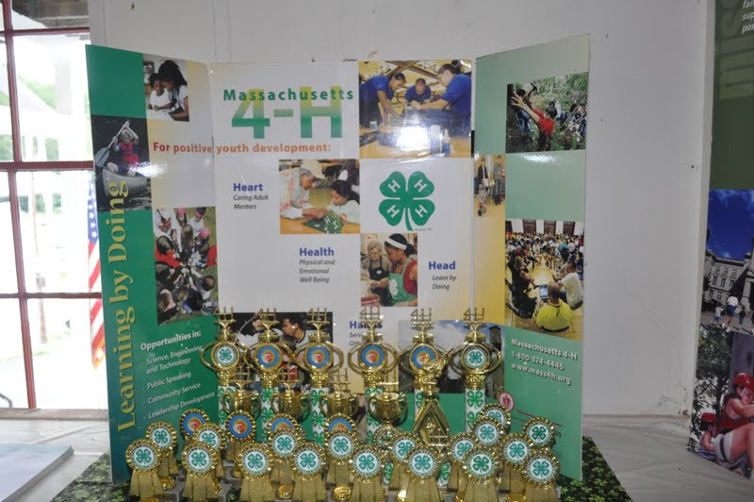

COMMONWEALTH OF MASSACHUSETTS
DEPARTMENT OF AGRICULTURAL RESOURCES/FAIRS

In addition to complying with all laws and regulations governing animal health issues all fairs must adopt and enforce the following rules for governance of the fair:
2017 Fairs- Animal Health Rules
NO animal will be admitted to the fairgrounds unless it meets the requirements below. NO animal is to be unloaded or enter a barn or tie-out stall until the animal and its paperwork have been inspected and approved for entry.
A. General Rules for All Animals: See M.G.L. c. 128 §2C, 129 §2
1. All animals must be in proper physical condition, be properly identified and free of visual evidence of infectious, contagious or parasitic disease at time of arrival. Specific diseases and conditions which will disqualify an animal for entry are identified for each species in the following sections of the rules. Animals of any species with open or draining wounds will not be approved for entry.
2. Evidence of infectious, contagious or parasitic disease or failure to produce the necessary documents for health certification, vaccination or testing will result in the animal's rejection for entry. THE INSPECTOR'S DECISION IS FINAL.
3. Any surgical procedure or injection of any foreign substance or drug or the external application of any substance (irritant, counterirritant, or similar substance) which could affect the animal's performance or alter its natural contour, conformation or appearance, except external applications of substances to the hoofs or horns of animals which affect appearance only, and except for surgical procedures performed by a duly licensed veterinarian for the sole purpose of protecting the health of the animal, is prohibited.
4. Official ID: See Final Rule: Summary of Traceability for Livestock Moved Interstate (Summary of general Requirements by Species)

All livestock must have proper official, individual ID as required for the species, e.g. official metal ear tag, tattoo, scrapie tag, or microchip. Registration forms must accompany health certificates when used as part of official identification.
5. Health Certificates: -- PLEASE NOTE CHANGES FOR 2017

One Official Certificate of Veterinary Inspection (OCVI) may be allowed for animals of the same species to be exhibited at fairs or shows in any of the New England states (CT, *ME, MA, **NH, RI, and ***VT) when submitted with an itinerary of the dates and locations of the events at which the listed animals are expected to be shown. Only animals that are healthy at the time of shipment may be moved. Note that *ME, **NH, and ***VT have additional requirements. Certificates of veterinary inspection in these states are valid for a shorter period of time and may have additional language, movement and permit requirements.
For the 2017 Show and Fair Season, livestock animals being exhibited in New England states must have official certificates of veterinary inspection (OCVIs) that meet the following requirements:
a. CT, MA, and RI: OCVIs issued on or after January 1, 2017 may be used for animals being shown at multiple fairs and shows in CT, MA, and RI through the 2017 show/fair season ending October 31, 2017.
i. ME: Exhibition season OCVI applies only to animals exhibited at Maine agricultural fairs from July 1 through October 31 and the OCVI must state ”For Exhibition Only”. An importation permit for exhibition animals is also required. Contact ME State Veterinarian’s Office (207-287-3701) for details and permits.
ii. NH: Animals exhibited in NH must originate in a New England state and move on OCVIs issued on or after April 1, 2017 to participating NH fairs and shows from July 1 to October 31, 2017. Contact NH State Veterinarian’s Office (603) 271-2404 for details and permits.
iii. ***VT: Contact the VT Animal Health Office (802-828-2421) for specific import requirements that deviate from the general information in this letter and must be met for legal import of livestock.
b. A single OCVI from the animals’ home state may be completed for travel to and from the New England states in which the animals will be exhibited. MA animals being shown ONLY in MA may substitute a signed, dated latter on the letterhead of an accredited veterinarian for an OCVI if all required information is included and all additional requirements are met.
c. Multiple animals of the same species may be listed on one health certificate with appropriate individual IDs and descriptions. Animals of different species may not be listed on the same official health certificate.
d. An itinerary of the names and locations for each New England fair or show at which owner expects to show the listed animals and the dates when each animal are expected to be on each site, must be prepared by the owner and presented to the veterinarian at the time the OCVI is written.

i. A copy of this planned itinerary must be attached to the official health certificate (import and export) for it to be used for more than one fair or show.
ii. That proposed list should be signed by the veterinarian and the owner/ exhibitor and reference the relevant OCVI number(s).
e. The name and address of the first show or fair where the listed animals will be exhibited is to be used as the “destination” on the OCVI form. In addition, “See attached list” or a similar statement directing Animal Health Officials or Fair Inspectors to the attached proposed itinerary must be included.
f. Exhibitors must keep an accurate list of the show locations and dates when their animals were actually on the show/fairgrounds. This record must be available to fair inspectors at each inspection and check-in.
g. Any animal listed on an OCVI that becomes sick must remain home. If the animal is refused entry to any exhibition during 2017 for health reasons it must have a new health certificate issued by an accredited veterinarian within 30 days of the next interstate movement.
h. Any New England state may end their participation in this agreement and revert to the standard published requirements for livestock imports in the state at any time, in the event of foreign animal disease outbreak or changes to state legislation.

ADDITIONAL REQUIREMENTS FOR EACH SPECIES ARE LISTED BELOW.
B. Cattle: See M.G.L. c. 129 §§2, 39 and 330 CMR 4.04(2).
1. TB and Brucellosis testing is not required for animals from TB-Accredited and Brucellosis-Free States and in-state animals. Current brucellosis and TB status in the exhibitor’s state can be obtained from the state veterinarian’s office in each state. If the exhibitor’s state is not TB-Accredited or Brucellosis-Free, then the exhibitor must call the Massachusetts Division of Animal Health for entry requirements (617-626-1795). All animals must be free of visual evidence of the following diseases and conditions: foot rot, mange, pink-eye, ringworm, warts, cow-pox and open or draining wounds.
2. While not required, it is strongly recommended that all cattle be currently vaccinated for rabies.

C. Poultry: See M.G.L. c. §§2, 129, and 330 CMR 5.02.
1. No poultry will be admitted to a fairground until it has been individually inspected.
2. All poultry must be free of visual evidence of the following diseases: infectious bronchitis, coryza, pullorum-typhoid, fowl-pox, external parasites and laryngotracheitis.
3. Each bird must be accompanied by written proof (ID card or test report) that the breeding flock was blood-tested negative for pullorum-typhoid within one year prior to entry date.
4. Birds from quarantined states will not be permitted entry.
5. All birds over 16 weeks of age as of January 1, 2016 shall be individually leg banded with a state leg band. This includes out of state exhibitors.
6. No bird vaccinated for laryngotracheitis within thirty days of the fair will be admitted.

D. Goats : See M.G.L. c. 129 §2, 9 CFR 79.6 and Massachusetts Emergency Order 1-AHO-06.
1. TB and Brucellosis testing is not required for animals from TB-Accredited and Brucellosis-Free States and in-state animals.
2. All goats and kids presented, regardless of age, must be individually listed and identified on the health certificate. All goats must be free of visual evidence of the following diseases and conditions: foot rot, mange, pink-eye, ringworm, warts, pox and open or draining wounds. All goats must also be free of sore mouth and scrapie exposure.
3. Based on the Federal Scrapie Eradication Program (FSEP), goats and sheep of any age or sex brought to show or exhibition from either out of state or within state must possess a USDA approved individual identification tag, tattoo, or electronic implant consistent with the requirements of the FSEP and the Massachusetts Emergency Order 1-AHO-06. Information on approved tags, tattoos, and electronic implants is available from the USDA-APHIS office in Sutton, MA at 508-363-2290.

E. Camelids (Llamas, Alpacas, etc.): See M.G.L. c. 129 §2, M.G. l. c. 131, §23 ,321 CMR 9.02.

1. TB and Brucellosis testing is not required for animals from TB-Accredited and Brucellosis-Free States and in-state animals. Current brucellosis and TB status in the exhibitor’s state can be obtained from the state veterinarian’s office in each state. If the exhibitor’s state is not TB-Accredited or Brucellosis-Free, then the exhibitor must call the Massachusetts Division of Animal Health for entry requirements (617-626-1795).

2. All Camelids originating from outside the Commonwealth are required to be tested for Blue Tongue. Exception: Animals from a USDA declared "Low Incident State" are exempt. Note: New England and New York are low incident states.
3. All animals must be free of visual evidence of the following diseases and conditions: foot rot, mange, pink-eye, ringworm, warts, pox and open or draining wounds.

F. Swine: See M.G.L. c. 129 §14E, 330 CMR 11.04(2), 9 CFR 71.19

1. All swine must be identified by an official ear tag or registration.
2. Swine must be free of visual evidence of the following diseases and conditions: erysipelas, atrophic rhinitis, mange and open or draining wounds.
3. No person shall import into Massachusetts from outside the state any swine which have been pseudorabies vaccinated. M.G.L. c. 129 §14E.
4. No person shall import into Massachusetts swine from Stage l or Stage ll Pseudorabies States.
5. All swine shall originate from qualified pseudorabies-free herds, or monitored herds in qualified pseudorabies free States only. The pseudorabies status of the exhibitor’s state can be obtained from the state veterinarian’s office in each state.

G. Sheep: See 9 CFR 79 and Massachusetts Emergency Order 1-AHO-06.
1. No sheep will be allowed entry from flocks in which Scrapie has been diagnosed or in which animals are under surveillance for Scrapie during the previous eighteen months. Based on the Federal Scrapie Eradication Program (FSEP) and the Massachusetts Emergency Order 1-AHO-06, sheep of any age or sex brought to show or exhibition from either out of state or within the state must possess a USDA approved individual identification tag, tattoo, or electronic implant consistent with requirements of the FSEP. Information on approved tags, tattoos, and electronic implants is available from the USDA APHIS office in Sutton, MA at 508-363-2290.
2. No sheep will be permitted entry from flocks in which Soremouth has existed or in which Soremouth Vaccine has been administered in the previous sixty (60) days.
3. Sheep must be free from visual evidence of foot rot, sore mouth, pink eye, ringworm, and open and draining wounds.
4. While not required, it is strongly recommended that sheep be currently vaccinated against rabies.

H. Equine: M.G.L. c. 128 §§2C, 44 , 330 CMR 16.05.
1. All equines entering a Massachusetts fairground must have a valid health certificate.
2. All equines must be free of visual evidence of the following diseases and conditions: mange, ringworm, soring, strangles, and open or draining wounds.
3. All equines originating from within and outside of the Commonwealth must have a negative USDA-approved
EIA test (i.e., Coggins test or ELISA test) dated within twelve months of entry.
4. While not required, it is strongly recommended that all equines be vaccinated for rabies, tetanus, EEE and WNV within one year of the fair.

I. Rabbits: See M.G.L. c. 129 §2
Rabbits must be free of visual evidence of the following diseases: snuffles, wet tail, skin and ear infections.
J. Dogs and Cats: See M.G.L. c. 129 §39G
1. All dogs and cats must be free of visual evidence of the following diseases: kennel cough, distemper, hepatitis, parvo, ringworm and mange.
2. All Massachusetts dogs and cats and those originating from out of this State must have a valid and current vaccination certificate for rabies.

All petting zoos are required to have a USDA APHIS Exhibitor’s License and valid health certificates. COMMONWEALTH OF MASSACHUSETTS
DEPARTMENT OF AGRICULTURAL RESOURCES/FAIRS
In addition to complying with all laws and regulations governing animal health issues (M.G.L. C. 129 §§14D, 14E, 44 and 330 CMR 4.03, 4.07, 16.03), all fairs must adopt and enforce the following rules for governance of the fair:

HAMPSHIRE COUNTY 4-H FAIR
July 8,2017
Cummington Fairgrounds, Cummington MA

General Rules:

- All animals and exhibits must remain until after the closing ceremony and awards. Prizes and premiums will be withheld for any infraction of the Fair rules.

- Eligibility - This Fair is open to all youth, you do not have to be a 4-H member to participate.
- Cloverbud – youth under age 8 as of 1/1/17 (Check each department you are entering for the
Cloverbud guidelines.)
- Junior - youth ages 8 through 10 as of 1/1/17
- Intermediate - youth ages 11 through 13 as of 1/1/17
- Senior - youth 14 through 18 as of 1/1/16. You may not have reached your 19th birthday as of 01/01/17.
- Novice – first year exhibiting
- Youth with developmental, intellectual or physical disabilities - ages 9 through 22 as of 1/1/17. Youth requiring accommodations should contact Tom Waskiewicz outlining the
accommodations being requested by June 1.

- All entries should be made on the official entry blanks enclosed. You may duplicate the entry form or request additional forms. The forms can be found online at: www.mass4h.org. Go to “News & Events,” then click on “4-H Fairs.” All entries must be postmarked by June 19th and mailed to the 4-H Office, AT Tom Waskiewicz, 101 University Drive, Suite A4, Amherst, MA 01002. Entries not postmarked by June 15th will have a fee imposed according to the department rules as stated in this fair booklet (usually double the regular department entry fee). Exhibit hall late entries will be charged $1.00 per class entered.

- All exhibitors are responsible to follow the rules of the department(s) they are entering.

- Only youth exhibitors are allowed to work on animals or exhibits at the fairgrounds.

- All exhibitors showing livestock must follow the dress code stated for their department.

- All livestock exhibitors must be present to exhibit their animals.

- Undesirable or poor quality exhibits may be refused by the department superintendent.

- The judges and superintendents reserve the right to refuse any exhibits that are not on the premium list. The decision of the judges is final.

- Placing will be given according to quality. The decision of the judges is final.

- All premium money will be paid from the awards as marked in the judges' books and not from ribbons that are attached to the exhibit, as ribbons are sometimes misplaced. Premiums will be mailed to exhibitors after the fair paperwork is completed. Premiums will be paid according to numerical placing within the class using the number of points as listed.

- Alcoholic beverages or the use of illegal drugs will not be permitted at this fair. No tobacco products in any building. These rules are in effect for the safety of all. Spectators and parents, as well as exhibitors are expected to abide by these rules.

- The Hampshire County 4-H Fair Association will not be responsible for the loss, theft, or damage to articles or animals that are being exhibited. The Fair will take every precaution to safeguard all exhibits.

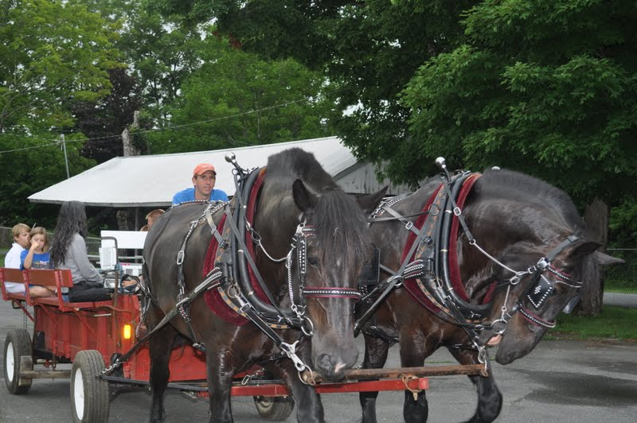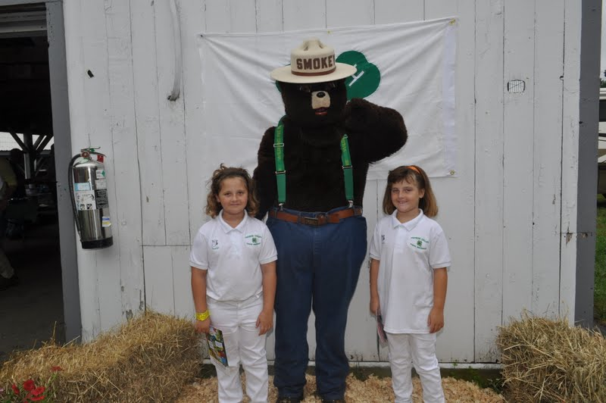
DEPARTMENT # 1 DAIRY CATTLE

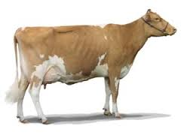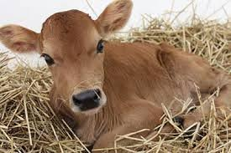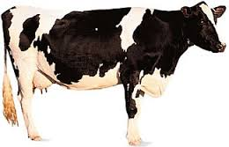

Superintendents and Show Secretary: Families of Hampshire County Cattle Club

All animals must remain until after the awards ceremony
- The dairy department will be open to receive animals on Saturday, July 8th between 7A.M. and 9A.M..
- Registration/lease and health papers must accompany animals to the show.
- All animals must be registered/leased in the name of the exhibitor prior to May1, 2017.
- All animals must meet state animal health requirements. All entries should be vaccinated against rabies.
- Exhibitors must fit own animals and must participate in a fitting and showmanship class.
- Fitting and Showmanship will be judged on the Danish system.
- Classes may be combined or divided at the discretion of the show secretary and superintendents
- Exhibitors must supply their own bedding. Exhibitors must clean their stable area at the end of the day or forfeit their premiums.
- Exhibitors shall make only one entry in a given class. Animals in-group Classes must be shown in a single class.
- Exhibitors must wear appropriate clothing for type, as well as showmanship Classes. All leaders in-group Classes must wear appropriate clothing. No bare feet at any time.
- Youth must be at least eight years of age to exhibit in the dairy department.
- Youth under 8 years of age as of 01/01/017 will be allowed to show only one animal.
- Cloverbuds will only show in the 2 designated Cloverbud Classes and will receive a participant ribbon and an award.
- An entry fee of $1.00 per head will be required and must be received with your entry. (Late entry fee will be $2.00)

Complete entry forms using the proper letter for the Section and number for the Class as listed below

SECTIONS & CLASSES

SECTION A: Fitting & Showmanship Premium Points: 50 – 45 – 40 – 35 – 30 – 25 – 20 – and all other worthy
*For age clarification see general rules

1. Novice (1st year) 2. Junior 3. Intermediate 4. Senior

Grand Champion Showmanship Class (no class #)

SECTION AC: Cloverbud (Participants will receive a ribbon and an award)
1. Cloverbud Showmanship Clinic

2. Cloverbud Breed Class

SECTIONS FOR ANIMAL BREEDS: Premium points: 50-45-40-35-30-25-20 and all other worthy

Section | Breed |  | Section |  | Breed |  | Section |  | Breed |  | Section |  | Breed
AY |  | Ayrshire |  | GU |  | Guernsey |  | JE |  | Jersey |  | MX  Grade |  | More than one breed used for Club Herd
BS |  | Brown Swiss |  | HO |  | Holstein |  | MS |  | Milking Shorthorn |  |  |  | More than one breed used for Club Herd

DAIRY CATTLE - CLASSES FOR ANIMAL BREEDS

Class | Class Description | Class | Class Description | Class | Class Description
5 | Spring Calf  (born March 1, 2017 or later) | 6 | Winter Calf  (born 12/1/16– 2/28/17) | 7 | Fall Calf  (born 9/1/16– 11/20/16)
8 | Summer Yearling  (born 6/1/16 – 8/31/16) | 9 | Spring Yearling  (born 3/1/16 – 5/31-16) | 10 | Winter Yearling  (born 12/1/15– 2/29/16)
11 | Fall Yearling  (born 9/1/15 – 11/30/15) |  | Junior Champion  (by breed)  winners from chasses 5-11 |  | Supreme Junior  Champion

lass | Class Description | Class | Class Description | Class | Class Description
12 | 2 Year Old  (born 9/1/14 – 8/31/15) | 13 | 3 Year Old  (born 9/1/13 – 8/31/14) | 14 | 4 Year Old  ( born 9/1/12 – 8/31/13)
15 | Aged Cow  ( born before 9/10)  (Classes 2 – 12 may be combined if there are less than three entries per Classes) | 16 | Dry Cow  Must have calved at least once
 | Senior Champion  (by breed) winners from Classes 12-16) |  | Grand Champion  (by breed) |  | Supreme Grand Champion
17 | Best Bred & Owned  (1 per exhibitor) ( 1 class for each breed) (Registration papers required at the show ring) | 18 | Produce of Dam  (two daughters from the same dam) | 19 | Dam & Daughter
20 | Exhibitor’s Herd  (Three animals owned by 1 exhibitor, must be all of one breed) | 21 | Club Herd  (Five animals owned by 3 or more exhibitors, may include more than one breed)

SECTION F: Fun Classes
- “Over the Hill” – fun class for 4-H parents and leaders may be combined with Beef Show (time permitting) – ribbon awards

- Leadline Class for youth not eligible for show, accompanied by youth eligible for show using an animal entered in the show may be combined with the Beef Show.

Awards: Ribbons & premiums in each class
* Rosettes and/or special awards to Junior, Senior, Grand Champions, & Supreme Champions Special awards to Champion Showman, Herdsmen Award Combine with Beef Show.

Herdsmen class will be judged on cleanliness of exhibit, interaction with public, care of animals, education of and promotion of project, and cooperation with other exhibitors and volunteers.

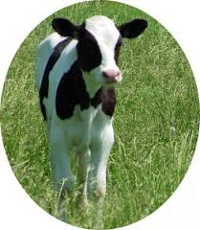
DEPARTMENT # 2 SHEEP

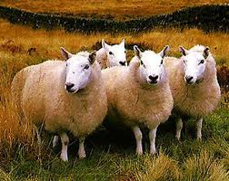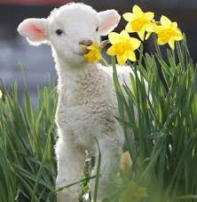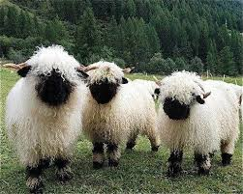

Superintendents: Alyssa and Megan Weld Adult Advisors: Julie Severance

All animals must remain until after the awards ceremony
- The sheep department will be open to receive animals on Friday, July7th from 4-7 PM and on Saturday, July 8th from 7:00-9:00 AM All sheep must be on the grounds by 9:00 AM The Sheep Show will begin at 9:30 AM in order to be done for the exhibitor meeting happening in the sheep show ring at the close of the Fair
- OVERNIGHT POLICY: Parents are responsible for supervision of exhibitors. Safety, appropriate 4-H behavior, and respectful care of the fairgrounds are expected.
- Please have all registration/health papers ready upon arrival. All sheep must be properly tagged in accordance with the Commonwealth of Massachusetts Animal Health Rules.
- Registration papers must indicate an individual – not a farm name.
- All animals must be owned/leased by the exhibitor prior to June 1, 2017.
- Exhibitors must supply their own bedding. Exhibitors are required to clean their pens at the close of the day, or premiums will be forfeited. Please bring your own brooms, shovels, pitchforks, etc. for cleanup.
- All exhibitors must enter showmanship. Please enter the proper showmanship section and class on your entry form.
- All exhibitors will follow the dress code of a clean white shirt or t-shirt and tan or white pants (no shorts) for showing. This rule also applies to those helping in group Classes.
- All animals shown in group Classes must be shown in individual Classes.
- Animals exhibited as market lambs may not be exhibited as breeding animals.
- Market lambs must be shorn on or after July 1, 2017.
- Youth must be 8 years old as of 1/1/17 to exhibit sheep in breed or market lamb Classes.
- Cloverbuds, youth 5-7 years of age as of 1/1/17, will only be allowed to show one animal.
- Cloverbuds will only show in the 2 designated Cloverbud Classes and will receive a ribbon and an award.
- An entry fee of $1.00 per head is required and must be sent with your entry. Late entries will be $2.00 per head.

Complete entry forms using the proper letters for the Section and number for the Class as listed below.

Premium Points: 30 – 25 – 20 – 15 – 10 – all other worthy 5

SECTION A: Fitting & Showmanship (age as of 1/1/17 or see General Rules)
Classes: 1) Senior (14-18) 2) Intermediate (11-13) 3) Junior (8-10) 4) Novice (first year exhibiting)

SECTION B: Cloverbud (Participants will receive a ribbon and an award)
- Cloverbud Showmanship Clinic (exhibitors age 5-7 as of January 1, 2017)
- Cloverbud Clinic Breed Class – 1 animal any age or breed all in ring at same time

ANIMAL BREED SECTIONS: For each animal, enter on the entry form the Section as found on this chart.

Section | Breed | Section | Breed | Section | Breed
CH | Cheviot | NC | Natural Colored | SU | Suffolk
CO | Cotswold | SH | Shropshire | TU | Tunis
DO | Dorset | SL | Shetland | UPM | Any Other Purebred – Meat
HA | Hampshire | SO | Southdown | UPW | Any Other Purebred - Wool
NOTE: Breeds may be combined or added as numbers warrant.

Age Classification for Breeds:

Cheviots &  Shetlands: | Senior Lamb:  9/1/16 - 2/28/17 | Southdowns: | Senior Lamb:  9/1/16 – 1/31/17 | All other Breeds: | Senior Lamb:  9/1/16–12/31/17
Cheviots &  Shetlands: | Junior Lambs:  3/1/17 and after | Southdowns: | Junior Lamb:  2/1/17 and after | All other Breeds: | Junior Lamb:  1/1/17 and after

For each animal, enter on the entry form the Class number as found on this chart for the appropriate age of the animal.

Exhibitors may have 2 entries per individual class (excluding yearling rams) and 1 entry per group class.
Class | Class Description | Class | Class Description | Class | Class Description
1 | Yearling Ram  (1 only) | 6 | Yearling Ewe | 11 | Produce of Dam  (2 animals, either sex, any age)
2 | Senior Ram Lamb | 7 | Pair of Yearling Ewes | 12 | Get of Sire  (4 animals, both sexes represented, any age)
3 | Junior Ram Lamb | 8 | Senior Ewe Lamb | 13 | Pen of Three Lambs  (bred and owned by exhibitor)
4 | Pair of Ram Lambs | 9 | Junior Ewe Lamb | 14 | Exhibitors Flock  (1 ram, 2 yearling ewes, 2 ewe lambs)
5 | Aged Ewe | 10 | Pair of Ewe Lambs | 15 | Breeders Flock  (1 Ram, 2 yearling ewes, 2 ewe lambs – all bred and owned)

SECTION 1ML: Market Lamb
1. Novice (first year exhibitor)/Scholarship 3. Lightweight Market Lamb
2. Heavyweight Market Lamb 4. Pair of Market Lambs

SECTION OC: Obstacle Course Ribbons only (to be done as time permits)
Classes: 1. Senior 2. Junior

AWARDS:
Rosettes to: Best ram and ewe of each breed, best ram and ewe of show and Champion market lamb
Special awards to:
All 1st Place Fitting and Showmanship
Champion Market Lamb
Supreme Champion Ram
Supreme Champion Ewe
Supreme Champion Bred and Owned (your best animal, any age either sex, only one per exhibitor)
Best Fleece
Outstanding Exhibitor – presented to the exhibitor who displays a positive and cooperative attitude. The quality and cleanliness of their area and humane treatment of animals are considerations.

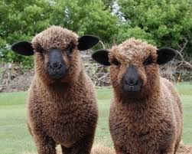

DEPARTMENT # 3 BEEF

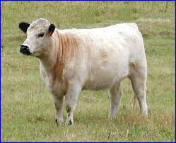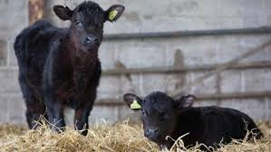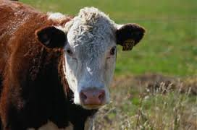

Superintendent: Roberts Family

All animals must remain until after the awards ceremony

- The beef department will be open to receive animals from on Saturday, July 8th between 7 and 9. Showmanship Classes may start later to accommodate travel time and animal preparation time.
- Exhibitors must supply their own bedding. Your stable area must be cleaned at the end of the day or premium money will not be awarded.
- All animals must have been owned/leased and cared for by the exhibitor by 5/1/17, and must be cared for by the exhibitor at the fair. Registration/lease and health papers must accompany the animal on July 8, 2017.
- All animals must meet state animal health requirements. All entries should be vaccinated against rabies.
- Beef exhibitors should present a neat appearance. Proper show clothes or white or pastel shirts with dark pants (ie. blue, black, dark green). Beef exhibitors have standards of dress which have been accepted by the beef industry (ie. western wear) Hard toe shoe or boots are required.
- Youth must be at least 8 years old as of 1/1/17 to exhibit in the beef department.
- Cloverbuds (7 years as of 01/01/17) will be allowed to show only one animal.
- Cloverbuds will only show in the 2 designated Cloverbud Classes and will receive a participant ribbon and an award.
- All beef breeds will be shown together. Classes may be split by breed if enough animals are entered.
- Beef animals cannot be shown in any other department.
- An entry fee of $1.00 per animal must accompany your entry. Late entry fee will be $2.00.

SECTIONS

SECTION A: Premium points: 50-45-40-35-30-25 all other worthy

Classes:
- Showmanship Senior ( for age clarification see general rules)
- Showmanship Junior (for age clarification see general rules)
- Showmanship Novice (first year exhibiting)

SECTION AC: CLOVERBUD (Participants will receive a ribbon and an award)

CLASSES:
- Cloverbud Showmanship Clinic
- Cloverbud Breed Class

SECTION B: BEEF STEERS

Classes:
- Under 1 Year of Age
- Over 1 Year of Age
- Grand Champion Steer (1st place winners from Classes 1 and 2)

SECTION C: HEIFERS

CLASSES:
- Spring Calf-born March 1, 2017 or later
- Junior Calf-(Jan1, 2017-Feb 28, 2017)Winter Calf-(Nov. 1,2016 - Dec. 31, 2016)
- Senior Calf-(Sept 1, 2015 - Oct 31, 2016)
- Summer Yearling-(June 1, 2016 - Aug 31, 2016)
- Spring Yearling-(March 1 2016 - 31, 2016)
- Junior Yearling-(Jan 1, 2016 - Feb 28, 2016)
- Senior Yearling –(Sept 1, 2016 - Dec 31, 2016)
Jr. Champion – 1st place winners from Classes 1-8

SECTION D: COW

CLASSES:
  - Cow 2 years and over
  - Cow 3 years and over
  - Senior Champion (1st place winners from 1 and 2)

SECTION E: GROUP

CLASSES:
- Cow/Calf
- Get of Sire (3 female animals that are progeny of 1 sire)
- Best 3 head (3 animals owned by 1 exhibitor)
- Club Heard (5 animals owned by 3 or more exhibitors, may include more than 1 breed)

SECTION F: Fun Classes

"Over the Hill" - fun class for 4-H parents and leaders may be combined with Beef Show. (time permitting) - Ribbon awards
- Leadline Class for youth not eligible for show, accompanied by youth eligible for show using an animal entered in the show. May be combined with the Beef Show.

Herdsman class Award Combined with Dairy Show Herdsmen class will be judged on cleanliness of exhibit, interaction with public, care of animals, education of, and promotion of project, and cooperation with other exhibitors and volunteers.

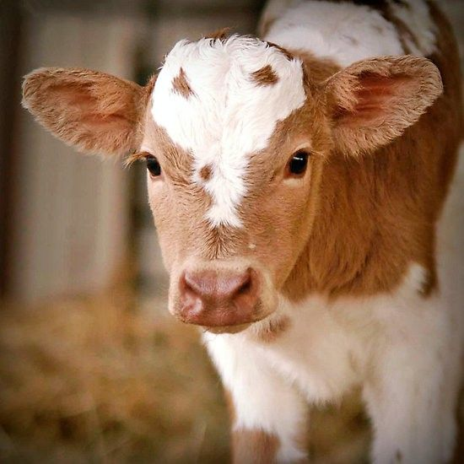

DEPARTMENT # 4 WORKING STEERS

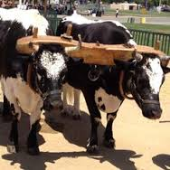

- All animals must remain until after the awards ceremony

- Animals will be in between 8:30 – 9:30am on Saturday, July 8th.

- The working steer show will be at 10:30AM.

- Proper show clothes are required. Tan or dark pants with white shirt. Hard toe shoes are required.

- Exhibitors are responsible for the clean-up of their stable area or they will not receive premium money.

- Juniors 10 and under as of January 1

- Senior 11 and older as of January 1

- An entry fee of $1.00 per team will be required and must be received with your entry.

- Entries are due June 19th late entry fee $2.00

Premium Points: 50-45-40-35-30-25 all other worthy

In the event of a demonstration class for 2017 there will be 50 premium points awarded to exhibitors.

SECTION A:

CLASSES:
- Showmanship Seniors
- Showmanship Juniors
- Stone Boat Seniors
- Stone Boat Juniors
- Cart Class Seniors
- Cart Class Juniors

DEPARTMENT #5 GOATS

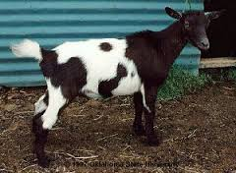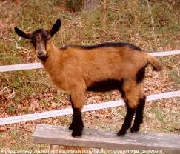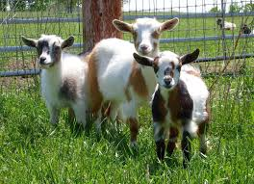

Superintendent: Brian Seiben
All animals must remain until after the awards ceremony
- Read Fair General Rules, 2017 Animal Health Rules, and Livestock General Rules.
- The goat department will be open to receive animals from 8:30 am to 9:30 am on Saturday. All animals must be on the grounds from 9:30A.M. and remain on the fairgrounds until after the awards ceremony. No animal may be unloaded until after they have been inspected and checked in with the goat superintendent.
- No horned animals will be allowed (exceptions will be made for market goats and fiber goats - horns must be tipped). No bucks allowed.
- Exhibitors must provide verification of ownership or lease in the exhibitor’s name by June 1, 2017, except kids must be raised and cared for from birth if born after June 1, 2017.
- A veterinarian’s health certificate must be presented before animals are unloaded. All tattoos will be checked. Registration papers are required for all ADGA registered does.
- No pre-show milk out required, but over bagged animals may be penalized in placing at the discretion of the judge and/or superintendent.
- Cloverbuds will be allowed to show only one animal and will show only in the two designated Cloverbud Classes. Cloverbuds may not show a horned animal. Cloverbuds do not need to own or have a written release for the animal shown to participate.
- All exhibitors in the Goat Division are required to wear while showing:
Girls: White shirt or T-shirt; tan or white pants, skirt or shorts
Boys:White shirt or T-shirt; tan or white pants or shorts
All exhibitors must wear closed toed shoes or sneakers at all times.
- All exhibitors should have a livestock card or signage indicating animal name and breed on display for each animal.
- Exhibitors must provide their own bedding. Each exhibitor must clean up pens and general goat area at release time or forfeit premiums. Please bring your own brooms, shovels, pitchforks, etc for cleanup.
- Exhibitors must fit own animals and participate in showmanship. Their showmanship animal must also be shown in a single goat class.
- All goats shown in a Specialty Class must also have been shown in an individual class.
- Please indicate the number of animal pens needed on the entry form.
Please see General Rules for Hampshire County 4-H Fair for due date for entries and where to send. An entry fee of $1.00 per animal must accompany your entry. (Late entry fee will be $2.00)
Premium Points awarded for Sections A, D-E: 30-25-20-15-10-all other worthy -5
Section A: Showmanship - All exhibitors must enter Showmanship.
Dairy Showmanship (including Dairy type goats)
- Senior (14 or over as of January 1, 2017)
- Junior (8 years and under 14 as of January 1, 2017)
- Novice (1st year showing & over 8 as of January 1, 2017)
Non Dairy Showmanship
- Senior (14 or over as of January 1, 2017)
- Junior (8 years and under 14 as of January 1, 2017)
- Novice (1st year showing & over 8 as of January 1, 2017
Section B: Cloverbud
- Cloverbud Showmanship Clinic (exhibitor 5 to under 8 as of January 1, 2017)
- Cloverbud Clinic Breed Class – 1 animal any age or breed all in ring at same time

Section C: Dairy Goat Breeds
Enter the breed letter with the class number. Breeds are shown in alphabetical order. In Classes 6-15, exhibitors may enter no more than two animals per class.

A =Alpine
B = Any other dairy type breed
L = LaMancha
N = Nubian
ND = Nigerian Dwarf
O = Oberhasli
R = Recorded Grade
S = Saanen
SA = Sable
T= Toggenburg

- Junior Doe Kid - 1 to 2 months
- Senior Doe Kid - 3 to 5 months
- Doeling - 6 months to under 1 year
- Yearling - 1 to under 2 yrs.; never freshened
- Yearling - 1 to under 2 years in milk
- Junior Doe Milker - 2 to under 3 years
- Intermediate Milker - 3 to under 5 years
- Senior Doe Milker - 5 to under 7 years
- Aged Doe - over 7 years
- Wethers

Specialty Classes: 1 entry per exhibitor per class
- Dam and Daughter
- Exhibitor’s Herd -3 does of 1 breed; at least 1 in milk
- Best Udder
- Produce of Dam - 2 daughters from one dam; dam to be named
- Get of Sire - 3 does from 1 sire; sire to be named

Section D: Meat / Market Goat (specify breed) Classes 25-29 are for meat goat breeds. In Classes 20-33, exhibitors may enter no more than two animals per class.
- Market Goat - animal entered in this class may not be entered in any other class in Section C. Animal must be part of a recognized 4-H Market Group Program.

- Junior Wether - up to 6 months old
- Senior Wether - 6 to 12 months old
- Doe Kid I - up to 3 months old
- Doe Kid II - 3 to 9 months old
- Senior Doe Kid - 9 to 15 months old
- Doeling - 15 months to 2 years old: never freshened
- Junior Milker - up to 3 years old
- Senior Milker - 3 years or older

Specialty Classes: 1 entry per exhibitor per class
- Dam and Daughter
- Exhibitor’s Herd - 3 does of 1 breed; at least 1 in milk
- Produce of Dam - 2 daughters from one dam; dam to be named
- Get of Sire - 3 does from 1 sire; sire to be named

Section E: Fiber Goat (angora, cashmere breeds) limit 2 entries per exhibitor
38. Fiber goat - under 2 years old; doe or wether 39. Fiber goat - over 2 years old; doe or wether

Section F: Utility Goat Danish Points: 15 - 10 - 5
Animal may not be entered in any class in Sections B, C, D or F. One entry per exhibitor per class.
- Pack Goat Obstacle Course Competition - animal must carry a pack with weight in it. Pack weight will be determined based on animal age and weight. A doe or wether may participate. Exhibitor must provide pack; obstacle course provided.
- Driving Goat Class - animal to be in harness pulling a cart or wagon. A doe or wether may participate. Exhibitor must provide equipment; obstacle course provided.

Section G: Ribbon Only Classes - 1 entry per exhibitor per class
- Companion Goat - goat kept for companionship; not for breeding. A doe or wether may participate; no bucks. All breeds and ages shown together. An animal in this class may not be shown in Sections B, C, D, E or F.
- Goat Costume
- Goat Obstacle Course

Section H: Herdsman No premiums paid.
To be judged on the criteria set by the American Dairy Goat Association and 4-H policy.
- Senior - exhibitor 14 to 18 years old as of Jan. 1, 2017
- Junior - exhibitor 8 to 13 years old as of Jan 1, 2017

Section I: Posters Premium Points: 5 - 4 - 3
- Goat Poster - A poster that presents a goat or goat produce theme. Name and age must be on back of poster
DEPARTMENT # 7 POULTRY
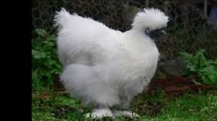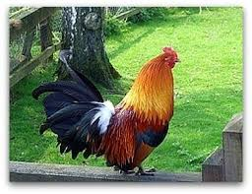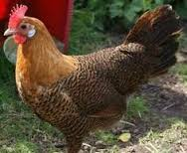
Superintendent: Sandra L Brougham
Animals must remain until after the awards ceremony
A COPY OF THE MA SALMONELLA/PULLORUM HEALTH CERTIFICATE WITH ENTRY FORM IS REQUIRED
- Entries are to be postmarked or dropped off by June19th
- There is an entry fee of $1.00 per bird for entries in Section S,B,P, and X Classes 1-5. (Late entry fee will be $2.00)
- Please specify the breed/variety of your bird on the entry form for these Classes.
- The Poultry department will be open to receive entries on July 8th from 8:00 a.m. to 9:30 a.m. All entries must be in place by 9:30 a.m. for judging.
- Cages, water, and shavings will be provided.
- All poultry will be inspected upon arrival. All birds must be clean and fully feathered. Any bird showing signs of disease will not be admitted. All poultry must have been blood tested by Mass. State Inspector for 2017. Exhibitors must present proof that birds are pullorum free (certificate or id card) upon arrival or birds cannot be allowed in. Waterfowl, broilers, and birds under 6 months of age do not have to be tested. To schedule testing for Hampshire County, contact Ed Hagman, 413-283-5214 well in advance of show time.
- Poultry area will be supervised, however Exhibitors will be responsible for birds at all times..
- All exhibitors must help with the cleaning of the poultry area at the close of the fair.
- All exhibitors are encouraged to enter in showmanship especially if you are a novice. This is a great learning experience.
- Poultry to be shown in poultry barn
- Show uniform is white dress shirt, or lab coat closed toe shoes black pants
Complete entry forms using the proper letter for the Section and Number for the number Class as listed below.
 | Section A: Showmanship
Class Number | 1 | 2 | 3 | 4
Description | Novice (ages8-19, first year of showing) | Cloverbud | Junior | Senior

Poultry Entries by Type Premium Points: 10 – 8 – 6 – 4 - 2
SECTION LETTER |  | S |  | B |  |  | P
 |  | Standard  (large) Size Fowl |  | Bantams |  |  | Production Poultry  (crossbred)
CLASS NUMBER |  | 1. Cock |  | 1. Cock |  |  | 1. Production  Pullett
 |  | 2. Hen |  | 2. Hen |  |  | 2. Production  Hen
 |  | 3. Cockerel (under 1 year of age) |  | 3. Cockerel  (under 1 year of age) |  |  | 3. Meat type  Female
 |  | 4. Pullet (under 1 year of age) |  | 4. Pullet  (under 1 year of age) |  |  | 4. Meat type  Male
 |  | 5. Trio (1 male and 2 female, same breed and age) |  | 5. Trio (1 male and 2 female, same breed and age) |  |  | 5.Market Turkey (male turkey)

SECTION LETTER | DB | DS | G | H | T
 | DUCK BANTAM | DUCK STANDARD | GUINEA FOWL | GEESE | Turkey
CLASS NUMBER
 | 1.SR. MALE | 1.SR. MALE | 1.SR. MALE | 1.SR. MALE | 1. SR. MALE
 | 2.JR. MALE | 2.JR. MALE | 2.JR MALE | 2.JR. MALE | 2. JR. MALE
 | 3.SR. FEMALE | 3.SR. FEMALE | 3.SR. FEMALE | 3.SR. FEMALE | 3. SR. FEMALE
 | 4.JR. FEMALE | 4.JR. FEMALE | 4.JR. FEMALE | 4.JR. FEMALE | 4. JR. FEMALE
Special Awards will be given for Best in Show, Best Showman, Best Novice, and Outstanding Exhibit/Poster.
DEPARTMENT # 8 RABBITS & CAVIES

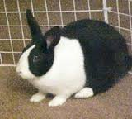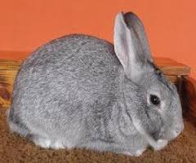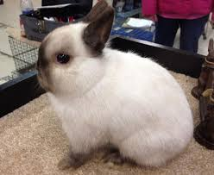

Show Secretary: Julianna Applegate Show Superintendent: Stephanie Thrasher
Adult Advisor: Nancy Searle

Animals must remain until after the awards ceremony

- This is an ARBA Youth sanctioned show and ARBA rules will be followed. This show is open to all youth, you do not have to be an ARBA member to participate.

- All entries must be postmarked by JUNE 15TH. Entry fees must accompany your entry. Entry fee per animal is $1.00. There is no fee for Classes D, E, F, G, H, and I

- All rabbits must have a permanent and legible tattoo in the left ear. All cavies must be properly ear tagged.

- This is a one day show. Exhibitors are responsible for bringing appropriate carriers to keep their animals safe and comfortable.

- Showmanship class requires a long sleeve shirt or a lab coat

- The rabbit department check-in will begin at 8:00am on Saturday, July 8th and ends at 9:00 am. All animals must be in place by 9:00am. Showmanship judging will begin at 9:30 a.m. Breed judging will begin at 10:30 a.m. All exhibitors must assist in the cleanup of the rabbit area.

- All animals showing signs of disease will be barred from the show and must be removed from the area.

- Only youth may carry animals to the judging table. No adults may assist with carrying or grooming.

- The Hampshire County 4-H Fair Association will not be responsible for loss or injury, every precaution will be taken against it.

- Cloverbuds: Youth under 8 years of age as of 1/1/17

- should sign up for Cloverbud sections listed for showmanship, rabbit identification, poster, written test and costume class.

- Entries in Section A and C must include breed, variety (and/or color) and ear number. See sample entry.

Complete entry forms using the proper letters for the Section and
number for the Class as listed below.

SECTIONS & CLASSES

Premium Points: 10 – 8 – 6 – 4 – 2 For Sections A, U, Y, Z

SECTION A: Rabbits Please include breed, variety, class # and tattoo number for each entry.
1. Senior Buck 2. Senior Doe 3. Intermediate Buck 4. Intermediate Doe 5. Junior Buck 6. Junior Doe

SECTION B: Cavies Please include breed, variety class # and ear tag number for each cavy.
7. Senior Boar 8. Senior Sow 9. Intermediate Boar 10. Intermediate Sow 11. Junior Boar 12. Junior Sow

SECTION C: Pets Pet Classes are open only to animals ineligible to be shown in Classes 1 - 12. Tattoos and ear tags are not required for pet Classes.
1. Senior Buck 2. Senior Doe 3. Junior Buck 4. Junior Doe
5. Senior Boar 6. Senior Sow 7. Junior Boar 8. Junior Sow

SECTION D: Showmanship

1. Cloverbud 2. Novice 3. Juniors 4. Senior

SECTION E: Rabbit Identification

Participants will be asked to identify rabbit breeds, equipment, etc.

1. Cloverbuds 2. Novice 3. Juniors 4. Seniors

SECTION F: Written Test

Test will include questions on care, breeds, etc.

1. Cloverbuds 2. Novice 3. Juniors 4. Seniors

SECTION G: Judging

Participants will be asked to place classes of 4 rabbits

1.Novice 2. Junior 3. Senior

SECTION H : POSTER

Informational poster that shows some aspect of rabbits or cavies
.
1. Cloverbuds 2. Juniors 3. Seniors

SECTION H: Costume Class

1. Cloverbuds 2. Juniors 3. Seniors

SECTION I

1) Educational Display educational display

SECTION J: RABBIT HOPPING

1.Cloverbud 2.Juniors 3.Seniors

Premium points for sections C, D, H, I, J, These Classes will be judged by the Danish System.

Blue 5 points Red 3 points White 2 points

Special Awards – Will be given for: Best in Show, Best Reserve in Show, Best Pet, Best Cavy, Outstanding Exhibitor (highest combined score from scores in showmanship, written test, and identification contest.

****SAMPLE ENTRY****
Dept | Section | Class | Describe Entry | Entry Fee | Breed | Sex | Color | Ear #
8 | A | 3 | Junior Buck Black Mini Rex | 1.00 | Mini Rex | Buck | Black | CJ03
8 | D | 3 | Junior Showmanship
8 | A | 2 | Senior Doe Rex | 1.00 | Rex | Doe | Broken Blue | JV545
8 | C | 2 | Senior Doe Pet | 1.00 | Pet | Doe | Sandy | none
8 | H | 2 | Rabbit

EXHIBIT HALL

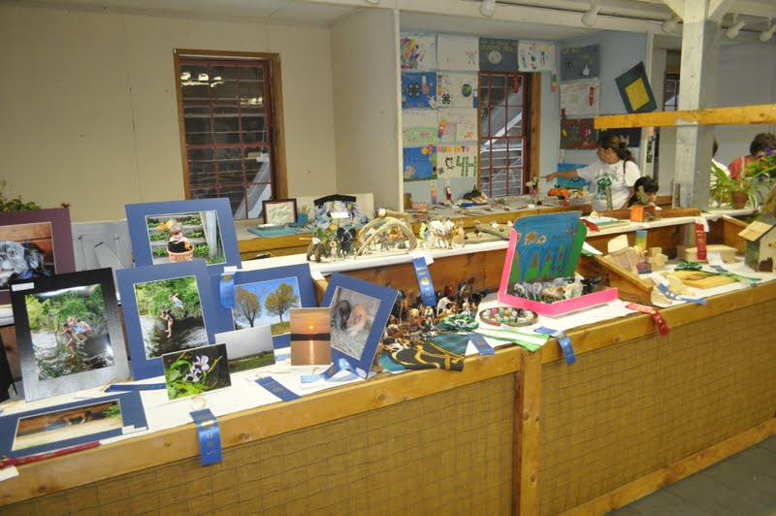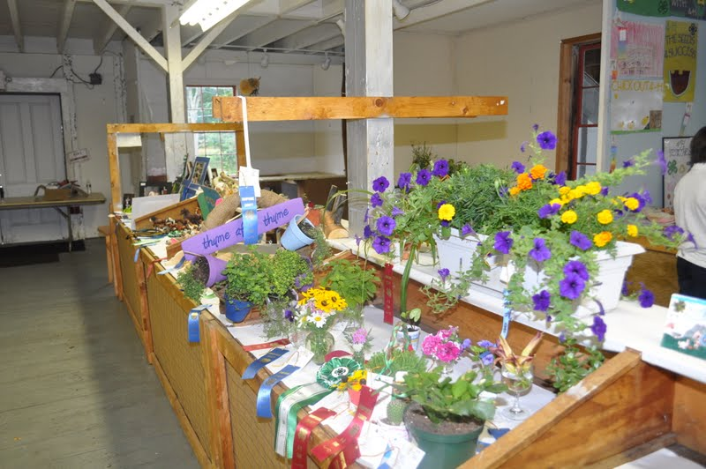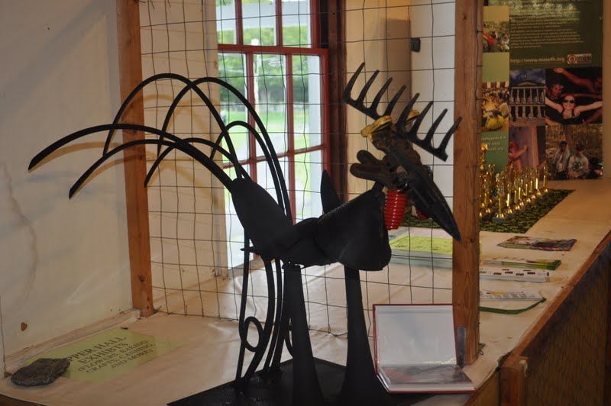

Superintendent: Nancy Searle

Exhibits must remain until after the awards ceremony

Exhibit Hall Classes will be divided as follows: (for age clarification see general rules)

A) Cloverbud (5 years and under as of 1/1/17) B) Juniors (8 – 10 yrs. as of 1/1/17)
C) Intermediate (11 – 13 yrs. as of 1/1/17) D) Senior (14 – 18 yrs. as of 1/1/17)
E) Special Needs

- All entries must be made in writing using the entry blank.
- All entry forms should be received by June 19th see general rules.
- All entries will be received from Thursday, July 6th from 1:00 to 7P.M.
- Judging will take place Friday afternoon. Exhibitors are not allowed in the hall during judging.
- No exhibits shall be removed before the awards ceremony on Saturday, July 8th. Exhibits must be removed by 6:00pm.
- The 4-H Fair takes no responsibility for any articles that are not picked up on July 8th.
- Articles must be made or grown within the last 12 months. Articles must be the exhibitors’ own efforts.
- The judges’ decision will be final. The judge can combine or split Classes due to size.
- Exhibits must be of good quality. The superintendents reserve the right to reject any exhibit due to its poor quality.
- Three or more entries of one project will constitute a new class.
- The 4-H Fair holds no responsibility for loss or damage to exhibits. Every precaution will be taken to safeguard exhibits.
- Exhibit hall entries (except Classes 1,2,& 3) will be judged by the Danish System. All quality exhibits will receive a ribbon. Blue ribbon = Excellent, Red ribbon = Very Good, White ribbon = Good. Entries that do not follow the rules as listed in this book will be disqualified.
- Points, unless otherwise stated will be: 8 – 6 – 4.
- Only one item per class per exhibitor will be allowed except where specified.
- Cloverbuds (youth under 5 years of age): -will be part of a special Cloverbud division. Cloverbud exhibits will receive Cloverbud ribbons Cloverbud exhibits will be displayed in a special area and special Cloverbud awards will be given.

DEPARTMENT # 9 EXHIBIT HALL AWARD CLASSES

SECTION A

- Homemaker Award (35 points) The articles made by the winner of this class will be displayed together. Non-winning entries will be re-entered in their respective Classes. Thus, if you don’t win the Homemaker Award, your work may still win in its respective class. Points are given for each entry. Winner must score a minimum of 80 points.
Requirements:

20 pts. – 1 sewn item – any material
20 pts. – 1 lunch box or place setting
20 pts. – 2 jars of canning – as listed in the fair book
15 pts. – 1 craft or woodworking item – as listed in the fair book
15 pts. – 1 baked good – pie, cake, or bread (scratch recipe only-recipe must be included)

DEPARTMENT # 9 EXHIBIT HALL AWARD CLASSES con’t

2. Handymaker Award (35 points) The articles made by the winner of this class will be displayed together. Non-winning entries will be re-entered in their respective Classes. Thus if you don’t win the Handymaker Award, your work may still win in its respective Classes. Points are given for each article. Winner must score a minimum of 80 points.

Requirements:
20 pts. – 1 repaired item – wood or metal
20 pts. – 1 picture and report of home project new or repair
20 pts. – 1 photograph – of project in progress
20 pts. Each – 1 crafts – recycled item

3. Green Thumb Award (35 points) The items in this class must be grown, selected and arranged by the exhibitor. The winning entry will be displayed together. Non-winning entries will be re-entered in their respective Classes. Thus, if you do not win the Green Thumb Award, your work may still win in its respective Classes.
Requirements:

20 pts. – 1 house plant – 20 pts. – 1 fresh floral arrangement
20 pts. – 1 plate of vegetables 20 pts. – 1 vase of cut flowers
20 pts. – 1 house plant – potted 20 pts. – picture and description of home garden
20 pts. – 1 potted vegetable 20 pts. – potted flower

4. Leader or Parent Class The 4-H Program would not be possible without the generous gift of time from many talented adults. We invite these many club leaders to exhibit in the hall. You must be a 4-H volunteer or parent of a fair exhibitor to participate. You may exhibit 1 article in any 1 class listed in the exhibit hall section. (Ribbon Awards).

DEPARTMENT # 10 CLOTHING/ CHILD CARE

SECTION B: Individual Premium points: Classes 1-15 8-6-4
1. Apron 6. Pocketbook/ tote bag/ backpack 11. Slacks
2. Blouse/shirt 7. Doll Clothes 12. Sportswear
3. Dress (formal/informal) 8. Accessory (headband, bows, etc) 13. Vest
4. Jumper 9 . Lined jacket or blazer 14. 2 Pc. Outfit
5. Any other sewn item 10. First Year Sewer Any article 15. Coordinated wardrobe of 3 – 5 garments

SECTION C: Child Care Classes 1 - 3 must be able to be safely played with by a child (No kits)

1. Doll 2. Stuffed animal or toy 3. Homemade game or toy of wood or metal

DEPARTMENT # 11 CANNING
All products shall be sealed by processing. Bands must be on Mason type jars. Jars must be of uniform size and labeling. Two jars in every class. Jam & jelly should be in 2 pint jars. All others may be pints or quarts.

SECTION D: Premium Points: 8 – 6 – 4
1. Any vegetable (2 jars) 3. Any pickle or relish (2 jars) 5. Any jelly (2 jars)
2. Any fruit (2 jars) 4. Any jam (2 jars) 6. Any relish (2 jars)

DEPARTMENT # 12 FOODS
Recipe must be included with all entries. No package mixes to be used, except class # 5. Entries must be displayed on disposable plates and be covered with clear plastic wrap. All foods will be sold to benefit the fair.

SECTION E: Premium Points: 8 – 6 - 4
1. Quick bread 6. Brownies or bars (6) 10. Decorated cake 14. Homemade candy (6)
2. Yeast bread 7. Chocolate Chip cookies(6) 11. Pie - one crust
3. Muffins, any type (6) 8. Any other cookie (6) 12. Pie - two crust
4. Cupcakes, any type (6) 9. Cake, any type 13. Fudge, any type (6)
5. Unique Mixes- package mix altered to make it unique. Include recipe telling how mix was altered

15.Lunch Box - Must include a menu for one full day. Food included must be for one meal only. Beverage may be listed, but not included. Nutritional value is important.

16 Fair recipe contest - Place setting, menu, one item prepared with recipe

DEPARTMENT # 13 ARTS & CRAFTS

SECTION A: Needlecrafts Premium Points: Classes 1-12 8-6-4
1. Knitted item 5. Macramé 9. Applique – hand
2. Crocheted item 6. Needlepoint or bargello 10. Applique – machine
3. Crewel & embroidery 7. Candlewicking 11. Plastic canvas
4. Latch hook 8. Counted cross stitch 12. Any other needlecrafts

SECTION B: Crafts All Classes Points 8-6-4
1. Wearable Art 13. Model vehicle 25. Holiday decoration ( up to 3 different holidays)
(stenciled, appliqué, sponge painting, etc.) 14. Model rocket 26. Needle felted item
2. Stenciling 15. Unsewn fabric craft 27. Reverse painting on glass
3. Candles (2) 16. Rock sculpture 28. Doll (apple, clothespin, etc)
4. Ceramics (from a mold) 17. Pompom creature 29. Dressed/decorated stuffed animal
5. Pottery (wheel or hand formed) 18. Handmade flowers (3) 30. Decorative painting on wood
6. Tie dyed item 19. Handmade jewelry 31. Paper cutting
7. Woven potholder (cloverbuds only) 20. Metal punch 32. Origami (5 mounted)
8. Plaster craft 21. Basketry 33. Memory Book (at least 10 pages)
9. Mobile 22. Nature Craft 34. Water Felted Item
10. Fairy Home 23.Bookmark 35. Slate Painting
11.Foam Craft 24.Lego Construction 36. Any other craft
12. Recycled Craft

37. Display of Crafts Premium Points 15-12-8
Collection of 5 or more objects of one type of craft chosen from Classes 60-85. Will be judged on quality, originality, and set up of display. Exhibits should be of high quality. Each display should not exceed 2’ x 3’ and exhibitors must supply backdrops, etc. if needed.
38. Hobby Collection Premium Points 15-12-8
Collection of 10 or more objects of one type of hobby collection. Will be judged on originality and set up of display. Exhibits should be of high quality. Each display should not exceed 2’ x 3’ and exhibitors should supply backdrops, etc. for their display as needed.

SECTION C: Education
1. Individual Educational Exhibit Premium Points 15-12-8
Will be judged on educational value, originality, quality and ability to tell a story. Exhibitor should supply backdrop etc for display as needed. Each display should not exceed 2’ x 3’.

2. Club Exhibits Premium Points 75-50-25
A 6’ x 3’ display which depicts club activities or a learning experience. A central theme should dominate the exhibit and tell a story.

SECTION D: Art Premium Points 8-6-4
Art must be original. No paint by numbers. Must be appropriately mounted or framed for hanging. Up to three entries per exhibitor per class.

1. Pencil Drawing 5. Drawing (crayons or pastels) 9. Sculpture
2. Colored pencil drawing 6. Oil painting 10.. Calligraphy
3. Charcoal drawing 7. Acrylic painting 11. Collage
4. Drawing (markers) 8. Watercolor painting 12. Any other art

DEPARTMENT # 14 QUILTING

Premium Points: 8 – 6 – 4

SECTION A: Quilting
1. Quilted Potholder 3. Quilted Pillow 5. Quilted Wall Hanging
2. Baby Quilt 4. Any other quilted item 6. Quilt

DEPARTMENT # 15 PHOTOGRAPHY

All photos must be mounted, labeled and taken by the exhibitor within the past 12 months. Photos may be color or black and white.

SECTION A: Premium Points: 8 – 6 – 4

1. Animal photo 6. 6 photos taken of a special event or trip
2. Photo of a person/s 7. 5 photos to show a sequence or tell a story
3. Scenic photo 8. Photo of a Hampshire County landmark
4. Family photo 9. Trick photo (ie, double exposure, use of mirrors, etc.)
5. Photo of the 2016 Hampshire County 4-H Fair

DEPARTMENT # 16 POSTERS

Posters are to be 14'" x 22" and may be vertical or horizontal

SECTION A: Premium Points 8-6-4

1. 4-H Fair theme 2. 4-H theme 3. Animal theme 4. Recycling Theme

DEPARTMENT # 17 CONSERVATION COLLECTIONS

SECTION A: Premium Points all Classes 8 – 6 – 4

1. Leaf prints mounted & named - at least 10 5. Rocks - mounted & named - at least 10
2. Native wildflowers - mounted & named - at least 10 6. Shells - mounted & named - at least 10
3. Leaves (pressed) - mounted & named - at least 10 7. Seeds - mounted & named - at least 10
4. Insects - mounted & named - at least 10 8. Any other conservation collection - at least 10

DEPARTMENT # 18 WOODWORKING

SECTION A: Premium points: Classes 1-8 and 9-12: 8 – 6 - 4; Classes 128-131: 12- 10-8

1. Wooden toy or game 5. Hanging rack or shelf 9. Chair
2. Bird house or bird feeder 6. Table 10. Any other wooden article
3. Breadboard 7. Bookcase 11. Wood carving
4. Footstool 8. Chest or cabinet 12. Wood burning

DEPARTMENT # 19 FRUITS & VEGETABLES
Classes 135-151 must be displayed on a paper plate.

SECTION A: Premium points 8 – 6 – 4

1. Beans (green) 15 pods 9. Lettuce - 2 heads 17. Tomatoes (green, stem on) - 5
2. Bean (yellow) 15 pods 10. Peppers - 5 18. Tomatoes (red, stems on) - 5
3. Beans (shell) 15 pods 11. Peas - 15 pods 19. Tomatoes (cherry) - 10
4. Beets (cut top to 1") 5 12. Radishes - 10 20. Carrots - 5
5. Cucumbers (long, green) - 2 13. Squash (summer) - 2 21. Any other vegetable
6. Cucumbers (pickling) - 5 14. Squash (zucchini) - 2
7. Raspberries (1pint) 15. Blueberries (1pint)
8. Strawberries (1 pint) 16.Any Other Fruit (1pint)
22. Display of at least 6 kinds of vegetables and/or fruit covering at least 3' x 3' display space. Must bring own peat, soil, or other table covering. (Premiums Points 15 – 12 - 8)
23. Display of at least 5 kinds of vegetables and/or fruits and greens arranged in an appropriate container (ie. basket or bowl) Premium Points 15 – 12 - 8

DEPARTMENT # 20 HORTICULTURE

SECTION A: HERBS Premium points 8 – 6 - 4

1. Pot of herbs (min of 3) identified 3. Ornamental (ie. potted, dried or cut in water)
2. Five herbs minimum of 5 stems each identified

SECTION B: FLOWER ARRANGEMENTS Premium points 8 – 6 - 4

1. Floral arrangement using wild flowers 5. Tiny arrangement -not to exceed 5" in any direction
2. Floral arrangement using dried flowers 6. Freedom reigns - arrangement in a container not
3. Potted flower intended for flowers
4. Live floral arrangement

SECTION C: FLOWERS Premium points 8 – 6 - 4

Must be grown, selected and arranged by the exhibitor. To be judged for horticultural perfection. Stems should include sufficient stem and foliage when practical. The number of blossoms is stated by class.

1. Cosmos - 5 blooms 6. Zinnias - large - 5 blooms 10. Rose - single - 1 bloom
2. Daisy - 5 blooms 7. Zinnias - small - 5 blooms 11. Roses - 1 spray
3. Bachelor buttons - 5 blooms 8. Snapdragons - 5 stems 12. Any other flower - 5
4. Marigold - large - 5 blooms 9. Petunias - 5 blooms
5. Marigold - small - 5 blooms

SECTION D: HOUSEPLANTS Premium points 8 – 6 - 4

1. Foliage houseplant 3. Hanging plant 5. Terrarium
2. Flowering houseplant 4. Cactus/ succulent 6. Dish garden

DEPARTMENT # 21 POULTRY PRODUCTS

SECTION A: Premium Points 8 – 6 – 4

1. 1 dozen pullet or small eggs (min. 18 oz) A) white B) brown 5. 1 dozen any other color
2. 1 dozen medium eggs (min. 21 oz) A) white B) brown 6. 1 dozen duck eggs
3. 1 dozen large eggs (min. 24 oz) A)white B)brown 7. 1 dozen jumbo eggs (min. 30 oz) 4. 1 dozen extra-large eggs (min. 27 oz) A) white B) brown A) white B) brown 8. ½ dozen any other eggs

DEPARTMENT # 23 COMPUTER SCIENCE

SECTION A: Premium Points 8 – 6 – 4

1. Poster- created on your computer (may include graphics- minimum size 81/2" x 11")
2. Report - computer generated report - at least 5 pages (may include computer generated graphs, photos, etc.)
3. Computer generated art
4. Other computer projects

DEPARTMENT # 24 Animal Science

SECTION A: Premium Points 8 – 6 – 4

1. Animal equipment made by exhibitor
2. Animal first aid kit made by exhibitor (indicate species)
3. Homemade animal treat (ex. Dog biscuits, horse cookies) plate of six include recipe
4. Homemade educational game-teaches some aspect of animal care, breeds, training, etc.

DEPARTMENT # 25 Janet Mollison Memorial
Club or family agricultural exhibits

SECTION A: Premium Points 75-50-35

Janet Mollison was an active 4-H member, parent and volunteer. Janet also served as the superintendent of this fair’s exhibit hall. The following classes honor Janet’s love of family, 4-H and the diary program.

At least 50% of class entries must be made/grown by youth. Exhibits are the combined efforts of adults and youth from one family or one club.

- Agricultural product display- (backdrop to be supplied by exhibitor)
- 5 different vegetables (from class list)
- 3 different cut flowers (from class list)
- 2 baked item (from class list)
- 2 canned items (from class list)
- At least 2 other agricultural products (ex. Eggs, herbs, maple syrup)

- Farmers Market Basket – to be displayed in a basket suitable for shopping at a farmers market.

3 different vegetables, 1 mixed bouquet of flowers, 1 baked item, 1 handcrafted item, 1 any other agricultural item

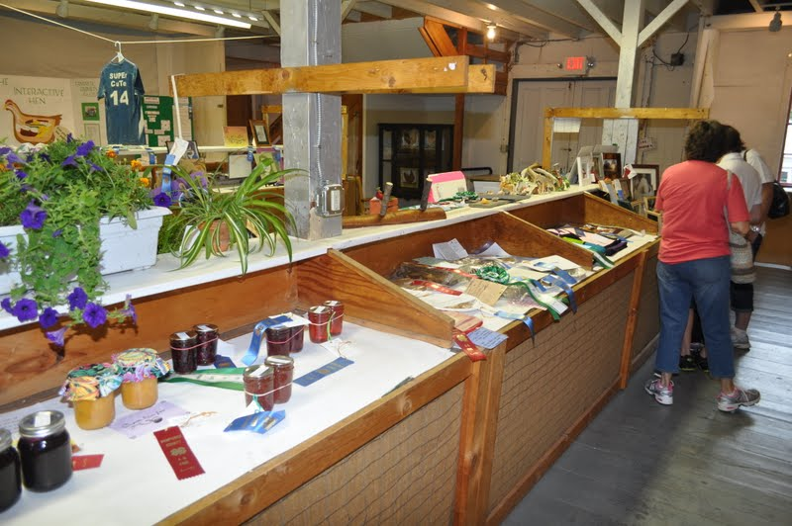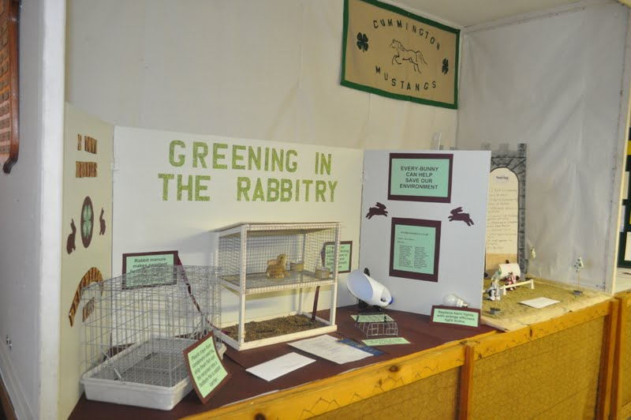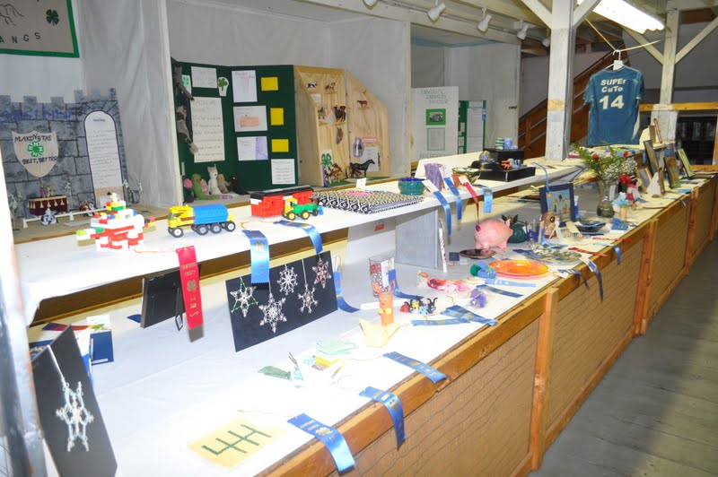

DEPARTMENT # 22 HAMPSHIRE COUNTY 4-H CHALLENGE DEPARTMENT

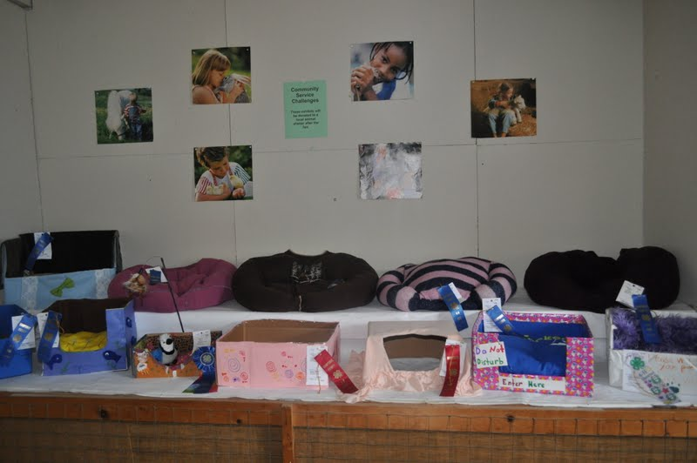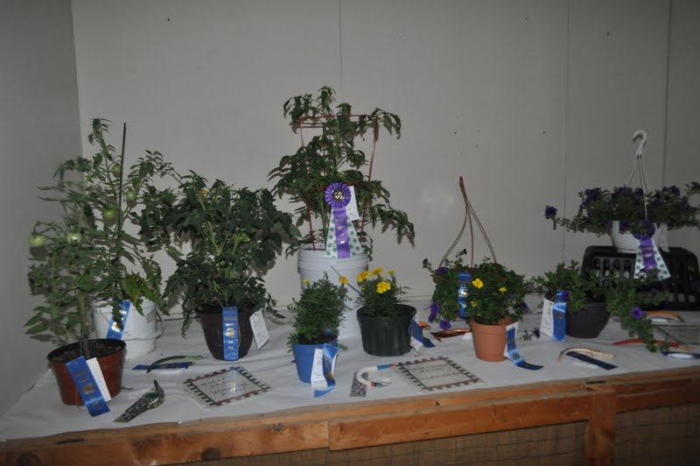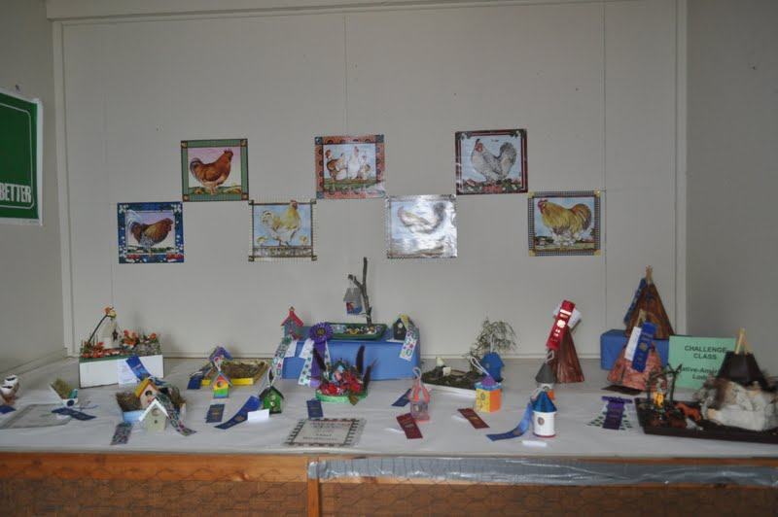
Superintendent: Nancy Searle

The Challenge Classes are an exciting addition to the 4-H Fair. In a Challenge Class, everyone starts out with the same materials and instructions, and the results are exhibited at the Fair. Challenge Classes require pre-registration in April. All challenge class participants must send in a written entry to indicate which challenge exhibits they are bringing to the fair. There is no entry fee to enter your challenge items.

Exhibits must remain until after the awards ceremony. All entries must be picked up between 5:00 pm - 6:00 pm on Saturday, July 8th

All challenge entries must be received or postmarked by June 19th.

All Challenge Class entries must be checked in between 1:00 – 7:00P.M. on Thursday July 6th Challenge Classes are judged under the Danish system and all entries receive ribbon awards. Trophies will be awarded to top entries.
SECTION A: YOUTH CHALLENGE CLASSES
1 | Book Tree | 2 | Picture Pillow | 3 | Design a Cap | 4 | Hot Plate
5 | Plaster Craft | 6 | Small Flag | 7 | 3-D Scene | 8 | Fabric Pony
9 | Egg Art | 10 | Coloring | 11 | Wooden Snake | 12 | Pine Cone Critter
13 | Tee Shirt Bag | 14 | Picture Frame | 15 | Decorated Wood Craft | 16 | Thank you card
17 | Bug House | 18 | Dog Bed | 19 | Cat Bed | 20 | Cat Toy
21 | Pillow Case | 22 | Totes for Tots | 23 | Personal Care Holder | 24 | Ornaments
25 | Tomato Plant | 26 | Marigold Plant | 27 | Sunflowers | 28 | Petunia Plant
29 | Cookies | 30 | Muffins | 31 | Muffins
SECTION B: ADULT CHALLENGE CLASSES
1 | Lap Blanket | 2 | Pillow Case | 3 | Totes for Tots | 4 | Hospital Bears
5 | Dog Bed | 6 | Cat Bed | 7 | Personal Care Holder | 8 | Ornaments
9 | Petunia Plant | 10 | Marigold Plant | 11 | Tomato Plant | 12 | Sunflowers
13 | 4-H Poster | 14 | Photography | 15 | Coloring | 16 | Cookies
17 | Muffins

SECTION C: CLUB CHALLENGES
1 | Club Banner | 2 | Club Scrapbook |  | 3 | Club Collage

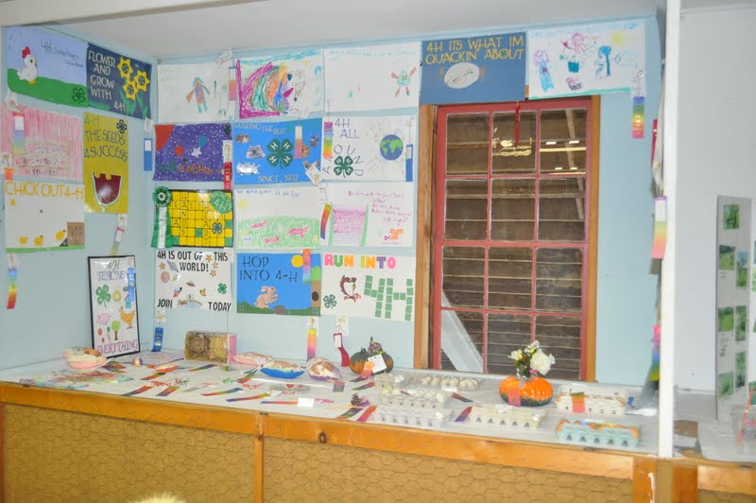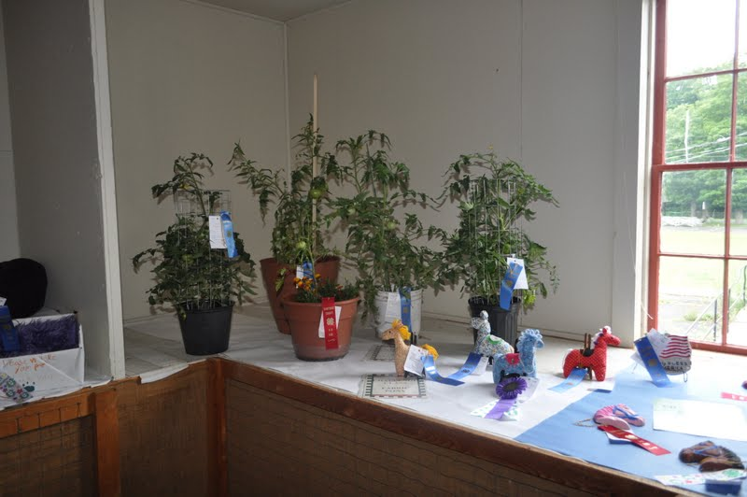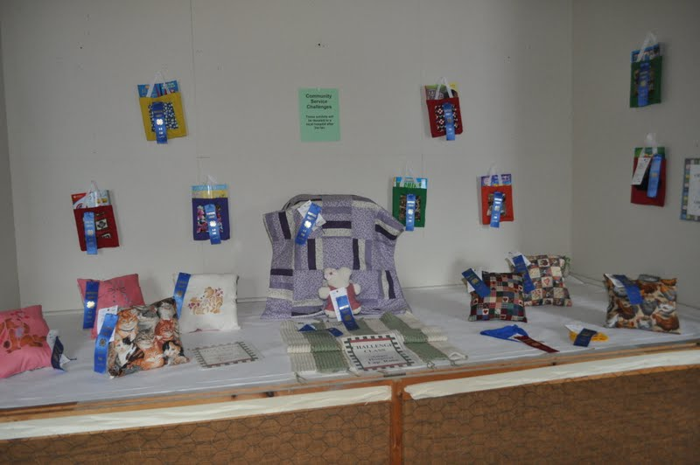

DEPARTMENT # 27 PETS
Superintendents: Misfits 4-H Club
Animals must remain until after the awards ceremony.

- All entries shown in this department may not be shown in any other departments.
- Entry fee of $1.00 per animal must be sent with entry.
- All entries must be in good health. Dog and cat exhibitors must bring a copy of heath papers showing current rabies immunizations.
- All entries must be cared for and handled by the exhibitor.
- All dogs and cats must be leashed – a crate is also recommended.
- All animals entered in Classes 3-5 must provide proper caging for their animal the 4-H Fair does not provide.
- Entries must arrive by 10:00 a.m. on July 8th and stay until after the awards ceremony, Judging of animals, costumes and tricks will begin at 1:00p.m.
- Youth are responsible for cleaning up after their animals.
- Judging in Classes 3, 4, & 5 will include evaluation of caging (cleanliness, proper food & water, etc.)

CLASSES

- Dogs
- Cats
- Small caged mammals
- Caged birds
- Caged reptiles & amphibians
- Small farm animals (ducks, chickens, rabbits)
- Other pets (goats potbellied pigs etc.)
- Costume Classes
- Pet trick class
- Pet care poster

- Pet Scrapbook – (notebook may include care information, veterinary records, photos, draws, etc.)

AWARDS: Danish Ribbons and Premiums for all quality entries.

- Danish Points: Classes 1 - 7 Blue-10 points Red-8 points White-6 points

- Classes 8 - 11 Blue-5 point Red-3 points White-2 points

- Rosettes and trophies for top entries.

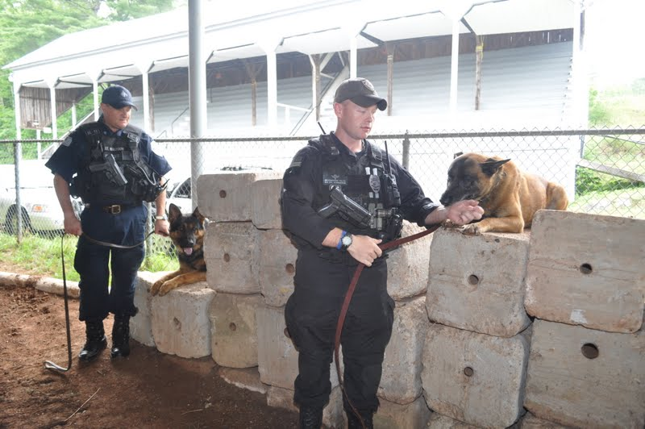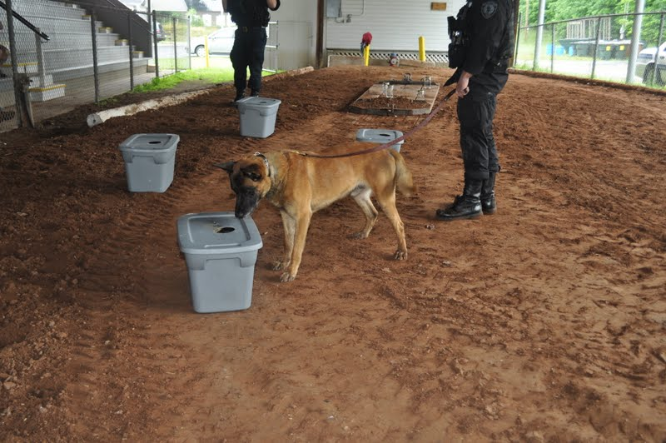

July 8, 2017 HAMPSHIRE COUNTY 4-H FAIR
REGISTRATION FORM

NAME 4-H MEMBER YES NO

____________________________________________________________________________________
STREET TOWN/CITY STATE ZIP

NAME OF 4-H CLUB COUNTY COUNTY ____________________________
AGE (AS OF 1/1/15) CELL/PHONE ( ) Email address __________________

DEPT. | SECTION | CLASS | DESCRIBE ENTRY | FOR ALL ANIMAL ENTRIES |  | FOR RABBITS AND POULTRY
 |  |  |  | ENTRY FEE | Breed | Sex | Variety | Ear #  Or Tags

Animal exhibitors must be sure to include breed and all other necessary information with their entry. Refer to departmental rules.

Page 1 of 2 of Registration Form

July 8th HAMPSHIRE COUNTY 4-H FAIR
REGISTRATION FORM

DEPT | SECTION | CLASS | DESCRIBE ENTRY | FOR ALL ANIMAL ENTRIES | FOR RABBITS AND POULTRY
 |  |  |  | ENTRY FEE | Breed | Sex | Color | Ear #  Or Tags

Animal exhibitors must be sure to include breed and all other necessary information with their entry. Refer to departmental rules.

Mail entry forms with fees by June 15, 2017 to:
MA 4-H Pioneer Valley Office,
Tom Waskiewicz,
101 University Drive, Suite A 4, Amherst, MA 01002

Page 2 of 2 of Registration Form

