Horse Project is for youth ages 8-18 as of January 1 of the current 4-H year

This record is for the current 4-H year only and relates only to the Horse Project. Submit a separate record for any other project. Do not repeat any information already listed in your Summary Record.

Name___________________________________________ Project year: Sept.1,_____ - Aug. 31,_____

Section 1: Project Goal(s) for the Current 4-H Year

My project goal(s) for this year is/are:
____________________________________________________________________________________

____________________________________________________________________________________

____________________________________________________________________________________

____________________________________________________________________________________

____________________________________________________________________________________

____________________________________________________________________________________

____________________________________________________________________________________

List steps that you will take to accomplish your goal(s):

____________________________________________________________________________________

____________________________________________________________________________________

____________________________________________________________________________________

____________________________________________________________________________________

____________________________________________________________________________________

____________________________________________________________________________________

____________________________________________________________________________________

____________________________________________________________________________________

____________________________________________________________________________________

____________________________________________________________________________________


Section 2: Project Summary – increase block size or add pages as needed

Month | Description of Project Work/Activities; include detail on what you did to reach your project goals | Hours Spent on Project | Expenses  (If any) | Income (If any)
September

October

November

December

January

February

March

April

May

June

July

August

Totals: | XXXXXXXXXXXXXXXXXXXXXXXXXXXXXXXXXXXXXXX

Section 3: Education
List any courses, workshops or other training that you have taken or attended this year to learn about the horse or equine science.

Name of course or  workshop | Description & number of hours | Who provided/taught the course or workshop

Section 4: Knowledge and Skills Gained
In bullet form list the most important knowledge and skills that you have acquired in this project during the past 4-H year. Be specific about what goals you have reached and what you have learned. Include “life skills” knowledge such as what you learned about yourself and others, managing resources, handling difficult situations, communicating with others and making decisions. Also include knowledge and skills gained that relate directly to the horse project.

____________________________________________________________________________________

____________________________________________________________________________________

____________________________________________________________________________________

____________________________________________________________________________________

____________________________________________________________________________________

____________________________________________________________________________________

____________________________________________________________________________________

____________________________________________________________________________________

____________________________________________________________________________________

____________________________________________________________________________________

____________________________________________________________________________________

Section 5: Life and Work Skill Development

Check the response below that best applies to your 4-H experience this year related to the horse project.

 | All of the time | Most of the time | Sometimes | Never | I had no opportunity to do this in 4-H
I had a plan for reaching my goals.
I took responsibility for my actions.
I was respectful of others.
I had the confidence to speak in front of groups.
I worked well with other youth.
I worked successfully with adults.
I liked working with others to solve problems.
I learned things that helped me to make a difference in my community.

INSTRUCTIONS

This project record is only one part of your complete record packet. The complete packet includes:
- A Summary Record
- 1-5 Project Records
- A 4-H Story; maximum of 5 double spaced pages
- We recommend that you include supplementary materials (maximum of 5 single sided sheets) to help tell your story that can include pictures, newspaper articles and other items.
All of the forms are found in the Communications section of the 4-H website at www.mass4h.org

Note: the name of this project is “Horse”, not the name of your horse. You may use this record to report on more than one horse.

Section 1 - Goals: It is important that you develop goals at the beginning of the year and work in a deliberate way to accomplish them. You may work with your club to set goals or establish your own. Select goals that will challenge you! If you do not accomplish all of your goals, you have not failed. Examples of goals for the horse project could be; “to learn how to do fitting and showmanship” or “to learn to care for my horse’s feet”. Next, you must break down each goal into steps that you will take to accomplish it. For example, some steps you could take to learn how to do fitting and showmanship with your horse could be: 1) learn how to properly show my horse by attending a fitting and showmanship clinic; 2) practice at home with my horse; 3) ask my leader and club members for tips on how to improve my showmanship skills.

Sections 2 & 3 - Project Summary and Education: Fill in the charts, as indicated. Be as specific as possible. Use numbers for hours worked, amounts of grain and hay purchased, etc.

Section 4 - Knowledge and Skills: In this section, you are asked to report what you learned through your involvement in the horse project this year. Refer back to your goals. Be as specific as you possibly can. Also, be concise and write this section in bullet statements. A bullet statement is not a complete sentence. Here are some examples of bullet statements that indicate knowledge and skills learned:

I learned:
- I have to clean his feet every day to keep my horse from getting thrush.
- I should use hoof dressing to keep my horse’s feet from being too dry.
- I need to practice often to do well in fitting and showmanship classes.

For older member, be more specific. This may mean that you use some complete sentences but use as few words as possible.
- How to evaluate my horse’s symptoms and decide when I need to call the vet. Some of the things I look for are…………
- I improved my skills in fitting and showmanship. Some of the things that I have done to improve are………………

Section 5: Life and Work Skill Development: Check one response for each question.

MA 4-H HORSE PROJECT VERIFICATION FORM FOR 4-H Year _______ to ______

Instructions  - Fill out one of these forms for EACH project horse.  - ALL the signatures below are required to be officially accepted as a registered horse project.  - Rider must wait 90 days from date received by county office to ride in 4-H classes or closed 4-H shows like the MA State and or the Regional Horse Shows.  - Riders should ALWAYS be ready to show horse Coggins/Shot records at every horse show.  - ALL SIGNATURES BELOW ARE REQUIRED  Member ____________________________ Date __________  Parent ____________________________ Date __________  Leader ____________________________ Date __________  Owner _____________________________ Date __________ | DRAW ALL MARKINGS, BRANDS, AND SCARS ON DIAGRAM.  TAPE OR STAPLE A 4 x 6 FULL VIEW COLOR PHOTO OF YOUR HORSE OVER THIS DRAWING SO IT CAN BE FLIPPED UP TO SEE THIS DRAWING.  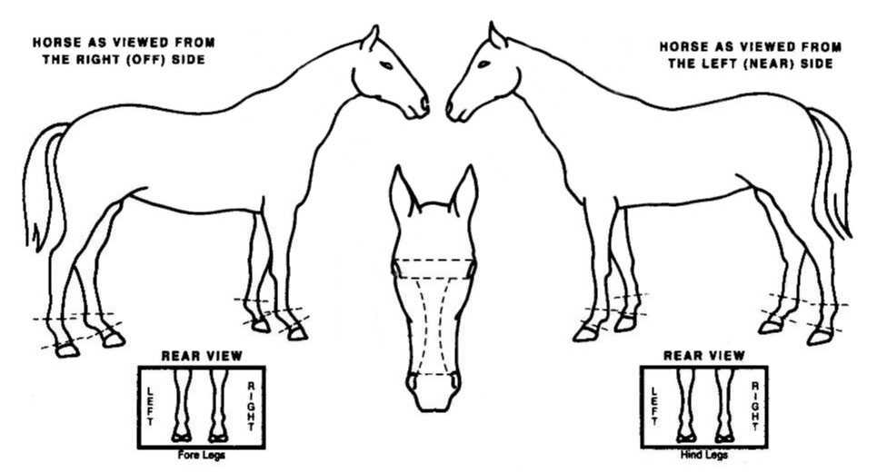
MEMBER INFORMATION HORSE INFORMATION
Member’s Name |  | Horse’s Registered Name
Date of Birth |  | Barn Name (if different)
Address |  | Age | (if unknown put age by teeth)
City, State, & Zip |  | Sex | Gelding Mare
Phone or Cell Number |  | Weight
Email address |  | Color
Years in 4-H |  | Breed
Years in 4-H horse project |  | Is this horse registered | No Yes Reg. #
Years with this project horse |  | Registration Association
Date started with this horse |  | Horse Ownership Level | Owned Leased
Club Name |  | Is this a Shared Project Horse | No Yes
County Registered In |  | Date Received at 4-H Office
SIGNATURES ON THIS FORM SIGNIFY THE INFORMATION IS ACCURATE AND HAS BEEN VERIFIED BY EACH SIGNER

