February 1, 2020

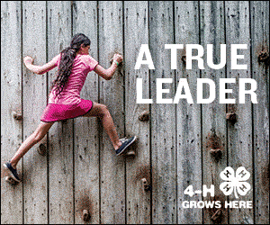

.

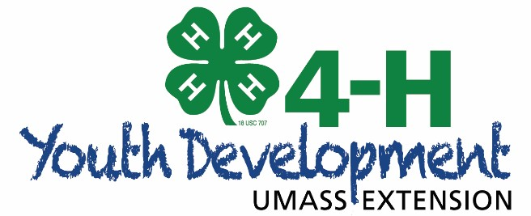

4-H Regional Winter Workshops 2020

WHO: All 4-H members, leaders, parents and families are invited to join Barnstable, Bristol, Norfolk and Plymouth County 4-H for our annual 4-H workshop series!

WHAT: A day of fun-filled, educational, hands-on learning activities.

WHEN: Saturday, February 1, 2020

Registration in Main Conference Room of Administration Building from 9:15-9:50 a.m.
Workshops are from 10:00 a.m.-3:00 p.m.
WHERE: Norfolk County Agricultural High School

400 Main Street, Rt. 1A

Walpole, MA 02081

COST:
$15.00 per 4-H member or sibling with a maximum of $45.00 per family; $5 charge for adult participants. Lunch is included in the price for each paid registration.

Breakfast: Coffee and donuts will be for sale in the morning.
Lunch: Pizza and Salad is included in the registration fee.
MEALS:
Please make checks payable to: Norfolk County 4-H Advisory Council.

MAIL REGISTRATION TO:

4-H Winter Workshops

4-H Office

400 Main Street

Walpole, MA 02081

SNOW: If there is a severe storm, we will cancel the event; there is no snow date. Money will not be
returned but will be used toward the event next year since materials will have already been purchased. In the event of bad weather, call the Norfolk County 4-H Office at 508-668-9793 to see if there is a
message cancelling the program. Remember that everyone must make their own decisions about whether the roads are safe to travel based on local conditions and their personal feelings!

Registration forms are accepted until January 25, but workshops are made on a first-come, first-serve basis! Get your forms in early for the best chance to get the workshop of your choice!
4-H Winter Workshops 2020

YOUTH AND ADULT WORKSHOP DESCRIPTIONS

SESSION 1

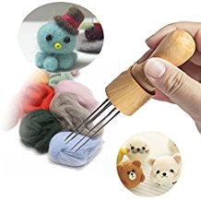

Wool Needle Felting: Everyone knows that sheep grow wool but in this workshop you will
have the chance to learn some fun facts about why this fiber is so amazing. We will also learn about felting. Everyone will make their own piece of felted fiber art to take home with them. Taught by 4-H volunteer Lauren O’Shea. For ages 8 and up.
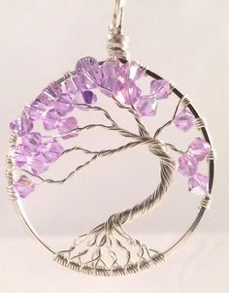
Tree of Life: Wires and beads are twisted on a hoop to create a unique tree that can be displayed in a window, on a wall, or a shelf. Taught by 4-H volunteer Christine Hoyt. For all ages.

Meet the Rabbit Breeds: Learn about a variety of rabbit breeds. Taught by 4-H volunteers –
Cindi Muller and Tricia Barry. For all ages.

Community Service Dog Beds: Shelters are full and they don’t have enough money for the little comforts of
home. Come to this workshop and make a dog bed for a local shelter. No sewing required. Taught by 4-H
volunteer Jennifer Moyer. For all ages.

4-H Record Book Online Now Available: Join Kim Pond in exploring this NEW opportunity of doing your 4-H
Records online. This will be an option for this year’s records and works in concert with 4honline. Your club and projects are already populated for you, so add your goals and get tracking your activities and inventory. Great for parents, leaders and youth. For all ages.

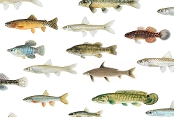
Fly Fishing: For many centuries, people have been trying to attract fish by mimicking one of their favorite foods: insects! Come learn about the history and some of the basics surrounding the delicate art and skill of fly fishing. Taught by Plymouth County Entomologist Blake Dinius. For ages
8 and up.

Operation Lifesaver Railroad Safety: Operation Lifesaver is a public safety awareness and educational program designed to save lives and prevent needless injuries and accidents on railways and rail-grade crossings. Each program has been designed by educators specific to that demographic, be they students in grade schools, professional driving schools, driver’s education students or school bus drivers. We hope to teach every and all persons with whom we come in contact to See Tracks, Think Train and Stay Off, Stay Away, and Stay Alive. Taught by Dana DeLorenzo. For ages 5-7 Clover Buds.

Winter and Early Spring Gardening 101: Learn some gardening tips for the early gardening and have some hands on
Planting. Taught by 4-H Parent – Sue Werner. For all ages.

Cats 101: Learn the basic introduction to cats. Taught by 4-H member – Brooke Usowicz. For all ages.

Club Officer Training: Learn how to become a great club officer. Taught by Norfolk County 4-H Ambassadors.
Ages 8 and up.

SESSION 2

Dairy Goat Care 101: What’s involved with leasing/purchasing a dairy goat, breeds, care of a goat- including
housing, fencing, medical requirements, feeding and showing a dairy goat and the associated costs of having a
goat. Taught by Horse Feathers 4-H Leaders and State Dairy Goat Workshop Leaders – Gina and Gabby Melnick.
Ages – 8 and up.

Oral Reasons for 4-H Horse Judging: This workshop will focus on learning to giving oral reasons for horse
judging contests – Taught by 4-H volunteer Channon Ames. For ages 8 and up.

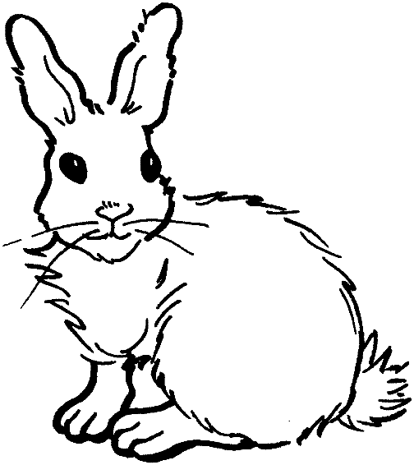
Basic Rabbit Care 101: Learn the basic care of raising a rabbit. Taught by Cotton Tails 4-H Leaders – Cindi Muller and Tricia Barry. For all ages.

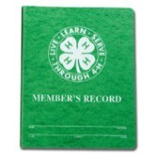
4-H Records: Easier than you think! Learn how to do 4-H records and why you should do them. Learn fun and interesting ways to keep track of your records. Taught by Round of A Paws 4-H leader Cathy Acampora. For ages 8 and up.

Hound Group (Dog Bingo): Learn about dog breeds and test your knowledge in a game of Dog Bingo. Taught by Amy Gentili and Ella Griswold. For all ages.

Astronomy: Let’s start off exploring what we know about our solar system with some simple activities and then learn how to peak out into the Universe. Taught by 4-H Educator Kim Pond. For all ages.

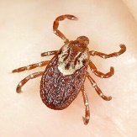
Defending Your Home Against Ticks: “What is a tick? How do they act? How can we stop them?”
Come learn how to identify the 3 medically significant tick species and learn smart tactics you can
use around your home and your body to stay safe.
Taught by Entomologist Blake Dinius. For ages 8 and up.

Hand Embroidery 101: Learn to embroider the 4-H clover. Taught by 4-H member and parent
Grace and Elizabeth Glazier. Ages 9 and up.

Operation Lifesaver Railroad Safety: Operation Lifesaver is a public safety awareness and educational program designed to save lives and prevent needless injuries and accidents on railways and rail-grade crossings. Each program has been designed by educators specific to that demographic, be they students in grade schools, professional driving schools, driver’s education students or school bus drivers. We hope to teach every and all persons with whom we come in contact to See Tracks, Think Train and Stay Off, Stay Away, and Stay Alive. Taught by Dana DeLorenzo. Ages 8 - 13.

Crafting for the Auction ADULT class: Plymouth County 4-H. Come help make items for the 4-H auctions to help raise funds. Taught by 4-H leader – Cathy Acampora - Ages - Adults

SESSION 3

Goat Soap Making: Participants will learn basic introduction and demonstration on how to make goat soap. Taught by 4-H volunteers Gabby and Gina Melnick. For ages 8 and up.

We Love Cloverbud Crafters: Make Valentine’s Day Cards – a great gift to give your “Valentine” or donate to decorate at a nursing home or shelter. Parents are welcome and encouraged to stay and join in the fun!! Taught by 4-H volunteer Debi Patuto. For ages 5 and up. This is great for our cloverbuds.

4-H & Google: A partnership to building Computational Skills. Come try some familiar activities and fun hands
on activities that will get you to see how you already are using things like Algorithms
And Pattern Recognition in your everyday life. Taught by 4-H Educator Kim Pond. Ages 8 and up.

Physics is Phun: Discover the amazing world of physics! Physics is a branch of science that studies matter and its motion, as well as how it interacts with energy and forces. Learn about gravity, electricity and force of motion.
Class will be taught by the Eco Explorer Science Club. Ages – 7-13; class limit 15.

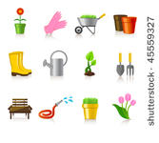
Planting for Pollinators: “It’s common knowledge that monarch caterpillars must feed on milkweed. This type of relationship is reflected throughout the world of insects. We will also discuss the close relationship insects and plant share, and review some butterfly and bee friendly plants you can grow yourself. Taught by Extension Entomologist Blake Dinius. For ages 8 and up.

Operation Lifesaver Railroad Safety: Operation Lifesaver is a public safety awareness and educational program designed to save lives and prevent needless injuries and accidents on railways and rail-grade crossings. Each program has been designed by educators specific to that demographic, be they students in grade schools, professional driving schools, driver’s education students or school bus drivers. We hope to teach every an all persons with whom we come in contact to See Tracks, Think Train and Stay Off, Stay Away, and Stay Alive. Taught by Dana DeLorenzo. Ages 14 up including Adults.

What is a Project Record and How do I do One?: Come learn how to do a project record and get yours started.
Learn hints to keep up with them so record keeping is easier. Taught by 4-H leader and Administrative Assistant Cathy Acampora. Ages 8- up.

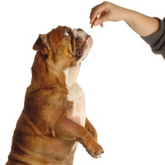
Dogs 101: Learn the basic introduction to Dogs. Taught by 4-H member –Brooke Usowicz and Christine Hoyt. All ages.

SESSION 4

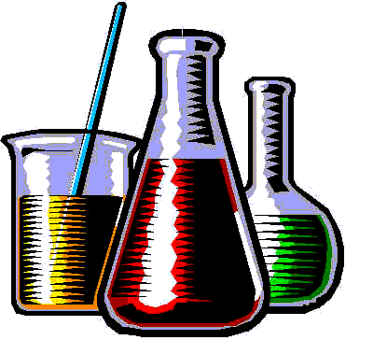
Chemistry & the Environment: Earth Day will be celebrating its 50th year so let’s explore polymers and the role and impact they have had in the environment. Taught by 4-H Educator Kim Pond. Ages 8 and up.

Glitter Jar Craft: Make a glitter jar craft. Taught by 4-H member Brooke Yoo. All ages.

Shrink Plastic Charms: Whether you are new or old, come join this class for all ages! Anyone can make their own custom plastic charms to put on your key chain, or on anything you’d like. Don’t know how? No worries we’re here to help you color, cut, bake, and create. We have plenty of supplies but feel free to bring your own colored pencils or markers if you
wish. Taught by 4-H member Lydia Lacorazza. All ages.

Leading the way through 4-H - Tips for leaders, parents and assistant leaders: Leaders and Assistant leaders come learn how to use the 4honline to your best advantage, simplify your enrollment process and learn about ways to communicate
better with your club. Taught by 4-H leader and Administrative Assistant Cathy Acampora. Ages – Leaders and Parents

War Dogs and Military Outreach: Community Service – Say Thank You to a soldier and a War Dog by making a card
And Tug Toy. Taught by 4-H members – Amy Gentili and Ella Griswold. Ages 8 and up.
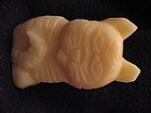

Soap Carving 101: Learn how to carve wood using a bar of soap. Taught by 4-H Parent Ellen Landerman .
Ages – 8 and up.

Scrap Booking Cards: Learn three cards using scrap booking techniques. Taught by Brooke Usowicz and Christine Hoyt.
Ages – 8 and up.

Make a Tote Bag: Participants will use a large colorful animal feedbag and bright colored duct tape to make their own large tote bag to bring to their 4-H events. Feedbags will be provided, you can bring one of your own if you prefer. Taught by Off the Grid 4-H leaders –Julie Silva and Corey Duclos. For all ages.

4-H REGIONAL WINTER WORKSHOPS - 2020 REGISTRATION FORM

Name (One per form) Street
Adult or Youth (give age)
Town
Parent Cell/Phone___________________Email_____________________________Club/County _______________________________________
You must fill out one form for each participant including adults who want to participate.
Make copies of this form, as needed.
Indicate your workshop choice (first, second and third choice) for each period. Write the number 1, 2 or 3 on the small line next to each workshop box to indicate your choice of workshop.
Cost: $15.00 per 4-H member and siblings with a maximum of $45.00 per family for the day. $5 charge for adults.

Period 1 – 10:10 to 11:00 Period 3 - 12:45 to 1:35
 | Wool Needle Felting – ages 8 and up |  | Goat Soap Making – ages 8 and up
 | Tree of Life – all ages |  | We Love Cloverbud Crafters – ages 5 and up
 | Meet the Rabbit Breeds – all ages |  | 4-H & Google – ages 8 and up
 | Community Service Dog Beds – all ages |  | Physics in Phun – ages 7-13
 | 4-H Record Book Online – all ages |  | Planting for Pollinators – ages 8 and up
 | Fly Fishing – ages 8 and up |  | Operation Lifesaver Railroad Safety – ages 14 up
 | Operation Lifesaver Railroad Safety – ages 5-7 |  | What is a Project Record – Ages 8 and up
 | Winter & Early Spring Gardening 101 – all ages |  | Dogs 101 – all ages
 | Cats 101 – all ages
 | Club Officer Training – ages 8 and up

Period 2 - 11:10 to 12:00 Period 4 – 1:45 to 2:35
 | Dairy Goat Care 101 – ages 8 and up |  | Chemistry & the Environment – ages 8 and up
 | Oral Reasons for 4-H Horse Judging – 8 and up |  | Glitter Jar Craft – all ages
 | Basic Rabbit Care 101 – all ages |  | Shrink Plastic Charms – all ages
 | 4-H Records – ages 8 and up |  | Leading the Way through 4-H - adults
 | Hound Group (dog bingo) – all ages |  | War Dogs and Military Outreach – ages 8 and up
 | Astronomy – all ages |  | Soap Carving 101 – ages 8 and up
 | Defending Your Home Against Ticks – 8 and up |  | Scrap Booking Cards – ages 8 and up
 | Hand Embroidery 101 – ages 9 and up |  | Crafting for the Auction – Adults Only
 | Make a Tote Bag – all ages
 | Operation Lifesaver Railroad Safety – ages 8-13

