Massachusetts 4-H Summer of Science
Workshop on Aerospace, Coding, and 4-H Resources
In Partnership with the Medway Library

Monday, May 6th, 2019 10am -noon

---------------------------------------------------

Register Through the Library at http://www.eventkeeper.com/code/ekform.cfm?curOrg=MEDWAY&curName=2019/05/06_Library_Workshop_on_Aerospace,_Coding,_and_4-H_Resources
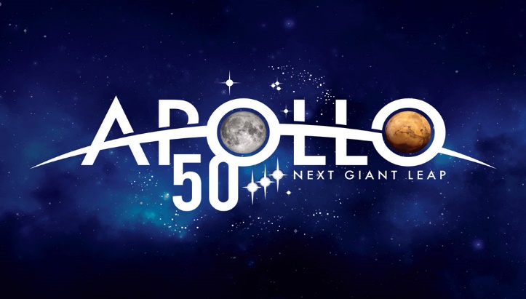

  - Gain new ideas for your Summer Reading Program “A Universe of Stories”

  - Try out some hands-on activities

  - Learn something new- What is computational thinking? (Computers and Exploration )

  - Explore additional 4-H Resources

  - Join in on summer rocket launches

