Club Leader Login
Before You Start
As a Club Leader, your enrollment must have approved and permissions assigned before you can login to the club.

Steps  1. Login to 4-H Online with your family’s 4-H Online email and password.  2. Locate your name in the list of members in your family.  3. Click the ‘View’ button next to your name. | Screenshots  (Screen appearance may vary per state)  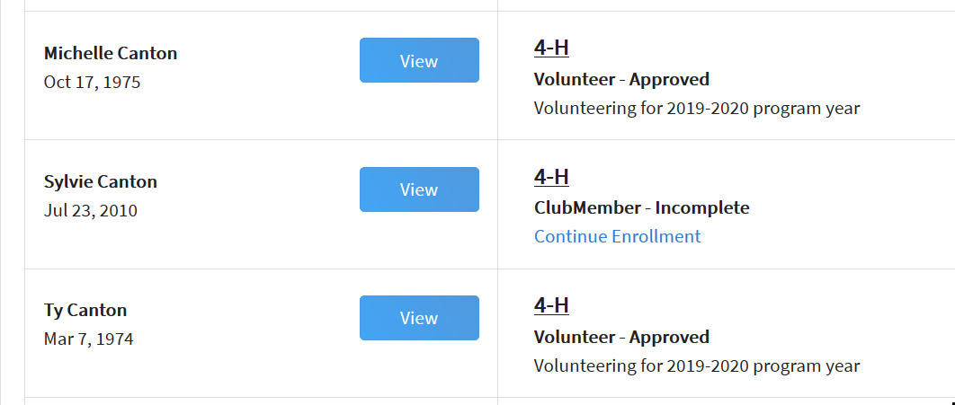
4. Click on Clubs in the navigation pane on the left side of the screen.  5. Click the Manage button for the Club. | 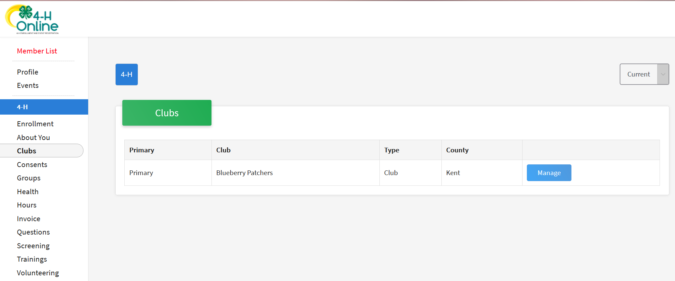
6. Enter the Unit (Club) PIN provided to you by the county office.
7. Click the Login button.
8. You will be able to download the Club Roster for your Club.  Additional functionality will be added soon! | 