A few sites I use a lot are Steve spangler (www.stevespanglerscience.com) & Makezine.com
I need to get some more things for wired for wind - so I put the numbers I found onsite in below for 2011

2008 - Hydrogels
Any diaper works so ask around and you might get some donated
Hydrogel- Powder (Water Gel - Sodium Polyacrylateform & Water Jelly crystals (steve spangler-https://www.stevespanglerscience.com/store/water-gel-magic-slush-powder.html
For the longer version - plain potting soil works fine - local ag or home improvement store

2009 - Biofuels
You may already have funnels and balloons, but most things you can get at a local grocery store or superstore
Have families save bottles for you

2010 4-H20
Most things you can get locally
In winter usually a pet store will give you some water that's a good starter for algae growth
Bromethyl Blue (Amazon or www.carolina.com)
*You can substitue and use an indicator like purple cabbage for pH (It is in several 4-H curriculum how to make "Kitchen Chemistry")

2011- Wired for wind
I've attached a sheet (DIY page final - with several options)
PVC Pipe for turbines 1" home depot
Dowels - home depot or craft store
Protractor - 4 4 Kidwind via vernier.com KW-BPP Kit
(Hub/25 dowels/generator) 10pk $135 Kidwind via vernier.com KW-BTPART10 (also signe sets $14) Kit
(Extra hubs) 3pk $30 Kidwind via vernier.com KW-BTH3 (also 10 for $66)

2012 - Ecobot
You can order vibrating motors from radioshack or similar store - or by kits
WE got toothbrushes and batteries from our local dollar tree store
http://makezine.com/projects/building-brushbot-kits/
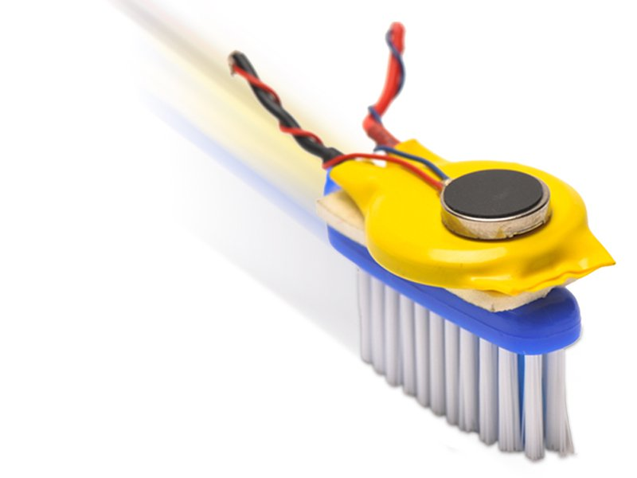 | Building BrushBot Kits | Make:  makezine.com  BrushBots are easy to make and fun to race!

Other supplies - craft and we had a lot of items .

2013- Maps to Apps
Not sure where you can get the large transparencies, but you can do on a smaller scale
I've also used vinyl from a craft store when I was practicing before the kits arrived and it worked.

2014- Rockets to the Rescue
You can use PVC pipe from the hardware store to make launcher (Often they may cut for you or ask if someone can help you as easier than doing with a hacksaw or something yourself)
*The book has the different lengths and connectors you need to build - so you can print and take with you to the store.
We have not bothered with corks when we have replaced as we have used clay or tape to cover in the end and they still add weight to balance.

2015 - Motion Commotion
Some kits were still available, but I also used (vinyl base board) from home depot for tracks and you can usually by in 4 ft sections in the store for about $4 each
For cars I started getting hotwheels since they are fairly heavy so work well and I've looked for one like a pickup truck or convertable that they could put a driver or something in from clay.
( I've tried some other cars from the dollar store, but axles not always on straight and inconsistent.)
Rulers and thinks easy to find.

2016 - Drone Discover
They still had kits, but you can order a Key camera online and the foam gliders I've gotten at walmart and dollar store in the summer as they need to be replaced after a time.

