**research SUMMARY:   
Evaluating the microbial risks of using DIY (Do-It-Yourself) MODIFIED washing machines for drying fresh produce**

Authors: Pavana Harathy Chennupati, Pragathi Kamarasu, Matthew D. Moore, Amanda J. Kinchla

|  |
| --- |
| research highlight  The Food Science team at the University of Massachusetts investigated the risk of microbial cross contamination due to small scale postharvest processing practices (DIY washing machines for leafy green processing) by developing a scientifically-based assessment of postharvest practices to identify risks; determined practical, easily-implemented measures for small scale production operations. The key findings and resources related to this project are summarized in this research brief. |
|  |
| Image of baby spinach leaves |

# Introduction

A team in the UMass Amherst Food Science Department recently completed a research study that evaluated the microbial risks associated with modified washing machines used for drying fresh produce. Small-scale producers often use modified washing machines to dry their fresh produce as a low-cost alternative to commercial drying units. These modified washing machines are cost-efficient, innovative, and have an effective production speed for drying leafy greens. However, the potential microbial risks of these units need to be better investigated, and the cleaning and sanitation guidelines for these units need to be established. Furthermore, cleaning and sanitation of food contact surfaces is mandatory according to the US FDA (CFR title 21, volume 2), and implementing the Food Safety Modernization Act has increased on-farm regulations.

Therefore, this research project aimed to address three primary research questions.

1. What is the overall contamination risk of using modified washing machines for drying leafy greens?

2. Can the contamination transfer from contaminated equipment to fresh, non-inoculated spinach?

3. Can modified washing machines for drying leafy greens be cleaned and sanitized to manage microbial risk effectively?

## **approach**

The team built a modified washing machine with the help of the [UVM EXTENSION AG ENGINEERING](https://blog.uvm.edu/cwcallah/2022/02/24/washing-machine-greens-spinner-conversion-guide/) team. The various parts of the washing machine (Speed Queen) were removed and rewired only to keep the central centrifugal force, the water-collecting drum, and the brake system intact. Perforated fishing baskets were used as loading buckets, which are in direct contact with the produce. Hence, in the end, the machine consists of 3 layers: a loading basket, an internal chamber, and a water-collection chamber, as depicted in Figure 1.

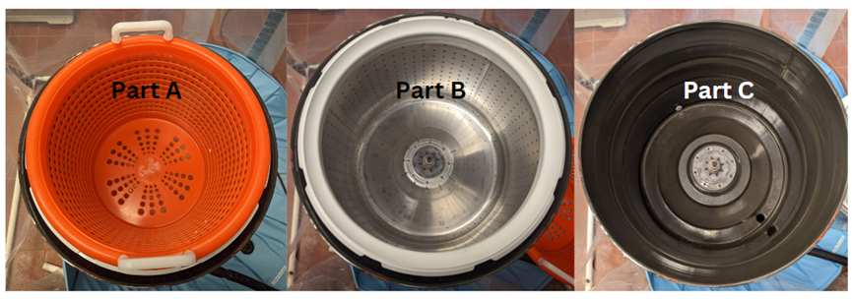

Figure 1. Top view of the different layers of the DIY modified washing machine labeled as A. loading basket, B. internal chamber, and C. water collection chamber.

Several foodborne outbreaks reported between 2006-2023 were associated with *Listeria monocytogenes* in various parts of the world [1] [2]. Vegetative pathogens, such as *L. monocytogenes,* are commonly present in any stage of harvesting, processing, packaging, transportation, etc., and contaminate fresh produce. *Listeria* can be present in fresh produce, and contaminated produce might result in severe illness*.* It is a resilient bacterium as it can survive even at refrigeration temperatures. With a high fatality rate in immune-compromised populations, listeriosis severity can range from moderate gastroenteritis to serious illness states (septicemia, encephalitis, meningitis, miscarriages, and stillbirths) [2]. To mimic this natural contamination, *Listeria innocua* (a non-pathogenic microbial strain of *Listeria monocytogenes*) was used in the experimental trials.

**results**

## What is the overall contamination risk of using modified washing machines for drying leafy greens?

*Listeria innocua* was inoculated onto fresh spinach at high (106 CFU/ml) and low concentrations (103 CFU/ml) for the experiments. Spinach samples were inoculated and dried, then washed and spin-dried in the modified washing machine. Post-drying, all three-unit layers were analyzed for the presence of *L. innocua*.

The results of microbial tests showed that even at lower contamination levels, there was a 98% and 99% spread of microorganisms from the produce to the modified unit at low and high inoculation concentrations, respectively. *L. innocua* was present on all three layers of the modified unit and specifically the immediate contact surface (loading basket), which had the highest microbial counts. The results signify that if there is produce contamination, irrespective of the level of contamination, the microbial spread can occur throughout the machine.

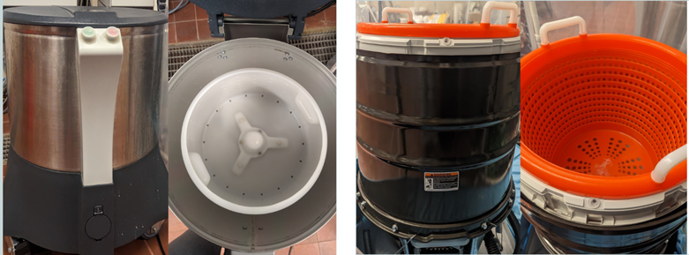

Figure 2. (left) Front and top views of a commercial drying unit (Electrolux vegetable drier COD 600095 VP2) and (right) a DIY retrofitted washing machine (Speed Queen TC5000WN).

The team also compared the modified washing machine with a commercial drying unit (Electrolux vegetable drier COD 600095 VP2), which only has two layers: a loading basket and a water collecting chamber (See Figure 2). The same experimental procedure was used for drying trials in both units, and the results were compared. There was a 92% and 93.5% spread of microorganisms from the produce to the commercial unit at low and high inoculation concentrations, respectively. The two layers of the unit had a microbial recovery, but the water collecting chamber had the highest.

The results indicate that the inoculated fresh produce contaminated both units had a statistically similar microbial spread. Both drying units pose a similar microbial risk, and using a DIY modified washing machine is not riskier than the commercial unit.

## Can the contamination transfer from contaminated equipment to fresh, non-inoculated spinach?

The next part of the study investigated the microbial transfer from contaminated equipment to fresh, non-inoculated spinach. The risk evaluation was conducted by inoculating the three surfaces of the modified unit (separately) directly with high concentrations of *L. innocua* followed by spin drying of fresh spinach. Results reported no microbial transfer from the indirect contact points in the 2nd layer and 3rd layer to non-inoculated fresh spinach. However, contamination of the direct contact surface (orange loading basket) resulted in the transfer of *L. innocua* to the fresh spinach. The results suggest that although cross-contamination was not observed at high levels when lower layers of the machine were contaminated, some transfer was observed to the leafy greens, which is a potential concern for *L. innocua* as it is psychotropic (can grow in cooler environments) therefore, there is potential for growing in refrigerated storage conditions.

## Does cleaning and sanitation significantly reduce microbial risk?

To determine if cleaning and sanitation reduce the microbial risks significantly, the modified unit was cleaned with food contact surface approved alkali-based Dawn Original Dish Detergent® (contact time 1min) along with potable water by using a clean scrub brush (Holikme, Amazon, USA). A complete removal of the suds and detergent is required to ensure the sanitizer's efficiency. This was followed by conducting initial comparative studies between two commonly used food contact surface approved sanitizers, such as peroxyacetic acid-based sanitizer (SaniDate 15.0 @110 ppm) and chlorine-based (Clorox @ 200 ppm). The results obtained showed that there was no statistical difference in the efficiency of both sanitizers. Hence, it is recommended that either one can be. It is important to ensure the sanitizers are allowed to air dry and that there was no application of water post sanitation. All three contact surfaces were evaluated for the presence of organisms post-cleaning and sanitizing. Post-application of the cleaning methods, the microbial recovery was below the limit of detection (<25 colonies/ml), and post-sanitizing, no residual microbial contamination was detected on all three contact surfaces.

In addition, the cleaning and sanitation practices were also applied to the Electrolux commercial dryer, and microbial recovery was determined. While the data was statistically similar to the DIY modified washing machine, results reported that even after the cleaning and sanitation step, there was still some detectable microbial contamination in the commercial unit, specifically in the bottom water collecting layer. This indicates that the modified washing machine poses no higher risk than the commercial unit.

**Note**: One important aspect to consider is that a sanitizing agent must be applied after the unit is fully cleaned, as the cleaning agent helps to remove the organic matter present on the food contact surface and helps to remove organisms that may have physically adhered to the food contact surface. The sanitizer is then applied to kill any residual microorganisms on the surface. **Direct application of sanitizer on the surface without cleaning is not effective as organic debris interferes with the activity of the sanitizer, and its efficiency is reduced** [**[6].**](https://www.cdc.gov/hygiene/cleaning/cleaning-your-home.html#:~:text=Surfaces%20should%20be%20cleaned%20before,germs%20on%20surfaces%20after%20cleaning.)

The goal of this work was to investigate the potential microbial contamination risks of DIY converting washing machines and investigate potential approaches that can help reduce these risks that can then be applied as a sanitation practice to improve food safety management.

# conclusion

The experiment result demonstrates that drying produce in the modified unit can result in equipment contamination. There is a possibility of contamination being transferred from the contaminated equipment to the fresh produce. However, in this study, there was no detection of listeria on the modified washing machine after cleaning and sanitation. This shows that cleaning and sanitation of the modified unit reduces the microbial risk and improves the safety of fresh produce. The researchers recommend that the immediate contact layer (perforated orange basket) be cleaned and sanitized daily at the end of the production day. Additionally, cleaning and sanitizing the entire machine at regular intervals, in addition to maintaining a proper record and conducting environmental swabbing, is highly recommended.

# resources

* [Washing Machine/Greens Spinner Conversion Guide (UVM)](https://blog.uvm.edu/cwcallah/2022/02/24/washing-machine-greens-spinner-conversion-guide/)
* Sanitation SOP for a DIY Modified Washing Machine to Spin Dry Leafy Greens
* [Food Safety for Farmers](https://ag.umass.edu/resources/food-safety/food-safety-for-farmers)

# references

1. Multistate foodborne outbreak notices. (2024, October 23). Foodborne Outbreaks. <https://www.cdc.gov/foodborne-outbreaks/active-investigations/all-foodborne-outbreak-notices.html>
2. Zhu Q, Gooneratne R, Hussain MA. Listeria monocytogenes in Fresh Produce: Outbreaks, Prevalence and Contamination Levels. Foods. 2017 Mar 9;6(3):21. doi: 10.3390/foods6030021. PMID: 28282938; PMCID: PMC5368540.
3. Chamberlin, A. (2022b, February 24). Washing Machine/Greens Spinner Conversion Guide – UVM Extension AG Engineering. <https://blog.uvm.edu/cwcallah/2022/02/24/washing-machine-greens-spinner-conversion-guide/>
4. Electrolux Professional 600095 VP2 Salad Spinner & Vegetable Dryer (20 gallons). (n.d.). Globe Equipment Company. <https://www.globeequipment.com/electrolux-professional-600095-vp2-salad-spinner-vegetable-dryer-20-gallons/>
5. Title 21 of the CFR -- Food and Drugs. (n.d.-b). <https://www.ecfr.gov/current/title-21>
6. When and how to clean and disinfect a facility. (2024, April 16). Water, Sanitation, and Environmentally Related Hygiene (WASH). <https://www.cdc.gov/hygiene/about/when-and-how-to-clean-and-disinfect-a-facility.html>
7. Program, H. F. (2024, February 5). Food Safety Modernization Act (FSMA). U.S. Food And Drug Administration. <https://www.fda.gov/food/guidance-regulation-food-and-dietary-supplements/food-safety-modernization-act-fsma>

|  |
| --- |
| Image of UMASS Food Science extension lab members working with modified washing machinesUmass food science Extension Logo |

UMass Food Science Extension

102 Holdsworth Way  
Chenoweth Laboratory

413-545-1017

[kinchla@umass.edu](mailto:kinchla@umass.edu)

<https://ag.umass.edu/food-science>