**SANITATION STANDARD OPERATING PROCEDURE (SSOP)**   
**FOR CLEANING AND SANITIZING A MODIFIED WASHING MACHINE USED FOR SPIN-DRYING FRESH PRODUCE**

**PURPOSE**: To clean and sanitize a modified washing machine to reduce cross-contamination of fresh produce.

**SCOPE**: Producers use modified washing machines to dry their fresh produce as a lower-cost alternative to commercial drying units. This paper provides an example of a standardized operating procedure (SOP) for the cleaning and sanitizing of modified washing machine units based on findings from research conducted by the University of Massachusetts, Amherst Food Safety Extension team. Modified washing machines (also known as a greens spinner) were built using a top-loading [Speed Queen TC5000](https://speedqueen.com/products/top-load-washers/tc5003wn/?bvstate=pg:2/ct:q) unit following the [Washing Machine/Greens Spinner Conversion Guide](https://blog.uvm.edu/cwcallah/2022/02/24/washing-machine-greens-spinner-conversion-guide/) provided by UVM Extension Agricultural Engineering team.

**FREQUENCY:**

1. If you are processing (drying) the same product on a day, the equipment should be cleaned and sanitized at the beginning and the end of the day.a
2. If you are processing (drying) different products in a day, it is recommended to clean and sanitize the equipment before shifting to different produce, beginning and at the end of the day.a

**PROCEDURE**:

*Pre-Cleaning*

1. Be sure that the operator thoroughly washes their hands before cleaning the greens spinner. Wearing personal protective equipment (PPE), including an apron, gloves, and eye protection, is recommended.
2. Disconnect the machine plug from the electrical outlet.
3. Manually remove the visible debris from the greens spinner unit and drain the water completely.   
   [Note 1: The water-collecting chamber can be connected to a water-draining pipe at the bottom, allowing water to drain automatically from the machine].

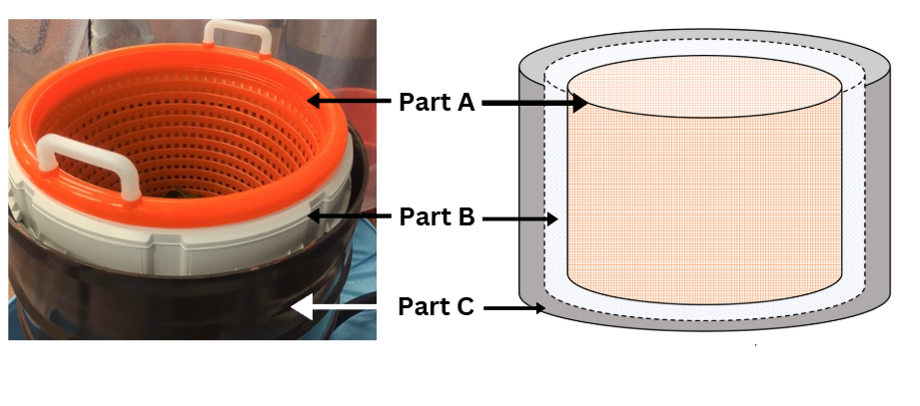Figure 1: Side view of the different layers of the modified washing machine labeled as A. loading basket, B. internal chamber, and C. water collection chamber.

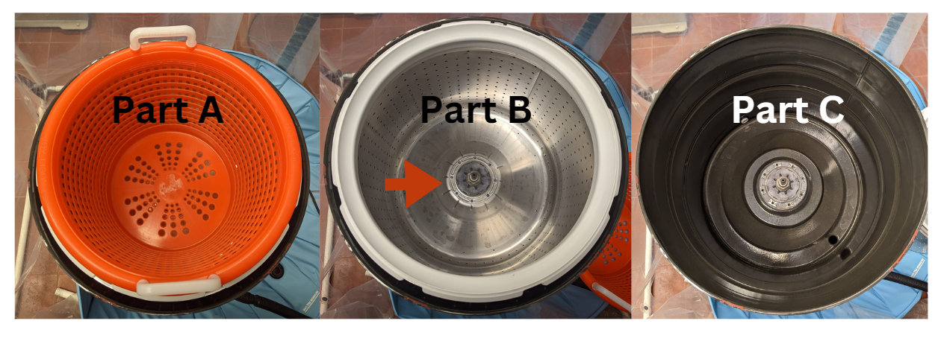Figure 2: Top view of the different layers of the modified washing machine labeled as A. loading basket, B. internal chamber, and C. water collection chamber.

*Disassembling the equipment:*

1. The modified washing machine unit contains 3 layers: loading basket (used for loading and unloading fresh produce), an internal chamber or drum, and the water collection chamber. Remove the loading basket (Part A) and place it on the previously cleaned and sanitized surface dedicated to cleaning. **DO NOT PLACE** the baskets on the floor.
2. Remove the bolts securing the drum (indicated with an arrow in figure 2) on the internal chamber (B) and separate the internal chamber from the water-collecting chamber (C).
3. Place the internal chamber (B) on a previously cleaned and sanitized surface dedicated to cleaning. DO NOT PLACE the chamber on the floor.
4. The water collecting chamber (C) should remain in the same position and will not be dismantled.

*Cleaning:*

1. Take an alkali-based P&G Professional Dawn original dishwashing liquid and read the directions for use.
2. Mix 4-5ml (about 1 tsp) of cleaning agent with 50ml of water and spray on the inside of all three layers (A, B, C) and the outside of layers A and B of the modified washing machine.   
   [Note 2: As the outer surface of part C does not contact the food, it can be cleaned and sanitized once a week to prevent cross-contamination]
3. Scrub all three layers using a clean, non-abrasive scrubber for ~1 minute (until the foam is produced). Ensure that the entire surface of all three layers is scrubbed until there is no more residual soil or debris on it.
4. Rinse all three layers with water until all the foam is washed away. Use a clean, non-scratch dish brush to scrub off any residual detergent suds. Rinse all three layers again with water until no dirt or debris is visible, then drain the water completely.
5. If there is noticeable soil or debris, repeat steps 1-4.
6. Use the same procedure to clean the bolts of the internal chamber. Apply Dawn's original dishwashing liquid ® to the bolts, scrub for about a minute, and clean with potable water.
7. All water should be drained completely. To reduce cross-contamination of the unit, ensure that the dedicated drying area is clean and sanitized before using the equipment.

*Sanitizing*

1. Ensure the surface of all three-unit layers is free of standing water.
2. Be sure that the operator is wearing proper PPE (i.e., eye protection, long sleeves, and gloves).
3. Prepare a 110ppm sanitizer solution by mixing 5 gallons of potable water in a bucket and adding 0.41-0.75 fl. oz of the sanitizing agent, SaniDate 15.0® (concentrated peroxyacetic acid-based). Refer to the manufacturer's directions before use.
4. Test the sanitizer concentration using Quantofix® Peracetic acid 0-500 test strips (Item number: 91341) to confirm that peroxyacetic acid is at least 110ppm but not greater than 200ppm of concentration. Dip the test strips in the solution for 1sec, shake off the excess liquid and wait for 15 seconds. Then, the resulting color can be instantly compared with the enclosed color chart on the test strip container to check the concentration. Do not move to the next step unless the concentration meets the target concentration (110ppm-200ppm).
   1. If the solution is *below* 110ppm, *add* more SaniDate 15.0® to meet the target (110ppm-200ppm).
   2. If the solution is above 200ppm, add more water to meet the target (110ppm-200ppm).
5. Transfer the prepared solution into a dedicated sanitizer spray bottle. Then, spray approximately 300ml (about 10.14 oz) of the sanitizer entirely inside all three layers (A, B, C) and outside of layers A and B continuously for at least 1min and let it air dry.   
   [Note 3: It is recommended not to wash off the sanitizer from the surface].
6. Use the same procedure to sanitize the bolts of the internal chamber.
7. Once the surface is sprayed with the sanitizer, place the internal chamber of the unit on the water-collecting chamber and replace the bolts using a drill or wrench.
8. Place the loading basket on the internal chamber.
9. The unit is ready for next use.

**MONITORING**:

1. A qualified team member must visually inspect the greens spinner for the presence of any debris before the production starts and after the production ends every day to ensure the cleaning and sanitizing procedure.
2. Record the concentration of the sanitizer solution every time after preparation using appropriate ppm test strips specific for peroxyacetic acid.
3. The qualified team member should record and sign the logbook after visual inspection (the format is given in the recordkeeping section). If the equipment is not cleaned and sanitized, implement corrective actions.
4. The production manager should ensure that the unit is cleaned and sanitized according to the standard operating procedure and that the logbook is reviewed to ensure that the unit is being cleaned and sanitized.

**CORRECTIVE ACTION**:

1. If the equipment is not cleaned or sanitized properly, the correction is to reclean and sanitize the equipment immediately.
2. If the cleaning and sanitizing are not followed according to the procedure, identify the root cause, and determine the actions needed.
3. If the sanitizer concentration is incorrect, a new solution should be prepared. Adjust the concentration by adding concentrated sanitizer if the ppm is below the limits or by adding water if it is above the limits before applying it to the food-contact surface.
4. If food residue or debris is observed on the equipment after cleaning and sanitizing, the equipment should be re-cleaned and re-sanitized. The personnel cleaning the equipment may need to be re-trained.

**VERIFICATION & RECORD KEEPING**:

1. After completing the cleaning and sanitizing procedure, record and update the physical logbook by the Production Manager using a pen.
2. An example of the format of a record is below:

Figure 1. Sample of a cleaning and sanitizing record for cleaning and sanitizing a greens spinner.

|  |  |  |  |  |  |  |  |  |
| --- | --- | --- | --- | --- | --- | --- | --- | --- |
| Farm: UMass Example Farm | | | | | | | Issued date: 1/4/23 | |
| Record: Cleaning and sanitizing of greens spinner log | | | | | | |  |  |
| SSOP: Refer to the CLEANING AND SANITIZING MODIFIED WASHING MACHINE USED FOR SPIN DRYING FRESH PRODUCE SSOP using 110PPM *SaniDate 15.0 ®)* | | | | | | |  |  |
|  |  |  |  |  |  |  |  |  |
| Production Date: __2/22/23____________________ | | | | | | | | |

|  |  |  |  |  |
| --- | --- | --- | --- | --- |
| Time of cleaning and sanitization | Condition & cleanliness of the green’s spinner  (S: satisfactory; U – unsatisfactory) | Sanitizer strength (target range 110-200PPM) | Comments and corrections | Operator initials |
| 11:05 AM | U | n/a | Visually not clean. Team lead re-trained the operator and then cleaned the machine again. | P.B. |
| 11:46 AM | S | 160 ppm |  | P.B. |
|  |  |  |  |  |
|  |  |  |  |  |
| Verification signature: Thomas Button  Date: 2/22/23 | | | | |

1. Employee training log: It is important to train the person responsible for cleaning and sanitizing the equipment to improve the efficiency of cleaning and sanitizing. Maintaining a training log helps the organization keep track of training as part of corrective actions.

|  |  |  |
| --- | --- | --- |
| Form Title: Employee Training record (Every time when the employee is trained) | | |
| Employee Name: | | Hire Date: |
| Employee Training Course | Location | Date Completed |
|  |  |  |
|  |  |  |
|  |  |  |

**REFERENCES:**  
a. *T*itle 21 of the CFR -- Food and Drugs. (n.d.). <https://www.ecfr.gov/current/title-21>

b. SaniDate® 15.0 – BioSafe Systems. (n.d.). <https://biosafesystems.com/product/sanidate-15-0-postharvest/>

[Note 4: The SaniDate 15.0 sanitizer used in this experiment is EPA-registered (Registration No. 70299-26), ensuring regulatory compliance. Additionally, as a peroxyacetic acid-based sanitizer, SaniDate 15.0 is approved for use in certified organic food processing and handling facility under the USDA National Organic Program Rule].

[Note 5: Refer [USDA CFR title 21- Part 178 subpart B](https://www.accessdata.fda.gov/scripts/cdrh/cfdocs/cfcfr/CFRSearch.cfm?FR=178.1010) for the list of approved sanitizers and their concentrations]

[Note 6: Personal protective equipment (PPE): Handlers who may be exposed to the undiluted product through mixing, loading, application, or other tasks must wear coveralls over long-sleeved shirt and long pants, rubber gloves, chemical resistant footwear plus socks, protective eyewear (goggles, face shield or safety glasses). Handlers who may be exposed to the diluted product through application or other tasks must wear long-sleeved shirt and long pants, and shoes plus socks].

**Research Notes:**

The efficiency of cleaning agent used in this study Dawn original dishwashing liquid was compared with P&G Professional Dawn Multi-Surface Heavy Duty Degreaser Spray® RTU (Ready to Use) and Simple Green all-purpose cleaner. There was no significant difference between the cleaning agents and all the surfaces had less than the limit of detection of microbial load after cleaning.

**Supplies sourced:**

|  |  |  |  |
| --- | --- | --- | --- |
| **S.no** | **Supplies** | **Supplier Name** | **Suppliers Product Name** |
|  | Speed queen washing machine | Manny’s Appliances at Hadley, MA, USA | Speed Queen TC5000 |
|  | PPE Kit (Lab coats, gloves, safety glasses) | Fisher Scientific, USA | Fisherbrand™ Disposable Lab Coats; Ansell TouchNTuff™ 92-616 Nitrile Gloves; Fisherbrand™ Clear Safety Glasses |
|  | SaniDate 15.0 (peroxyacetic acid sanitizer) | Biosafe Systems, USA | SaniDate 15.0 |
|  | P&G Professional Dawn original dishwashing liquid | Amazon, USA | Dawn Ultra Dish Soap, Dishwashing Liquid, Original, 4x24 Fl Oz Bundle |
|  | Non-abrasive scrub | Amazon, USA | Scotch-Brite™ Non-Scratch Scrub Sponges (Individually Sealed) |
|  | Non-scratch dish brush | Amazon, USA | Holikme Kitchen Cleaning Brush, Green |
|  | Electrical Drill | Amazon, USA | BLACK+DECKER 20V MAX* POWERECONNECT Cordless Drill/Driver + 30 pc. Kit (LD120VA), Orange |
|  | Spray Bottles for sanitizer | Cole-Parmer, USA | Cole-Parmer HDPE Trigger Spray Bottle, 22 oz; 4/PK (EW-06091-05) |